*Kazmi, Imran H - 1703556*

*Primary supervisor [Dr Michael Sanderson] | [Dr Riccardo Poli]*

*Computer Science*

*Re-creating A Classic 2D Arcade Game*

**Abstract**

The project I have chosen to pursue is to recreate a classic arcade game. I decided to do this with no prior experience in creating a game and decided to use my own take on what it means to have a ‘classic’ game. I decided to take inspiration from two games I played growing up; the first being the Super Nintendo version of T’he Legend of Zelda’ and the second being ‘Box Head’. I believe taking inspiration from games that have been experienced by different generations of people would appeal to a wider audience as this way they would both recognise parts from their beloved childhood games.

Throughout the creation of the game I have attempted to stay true to the classic 2D pixellated theme of the game which is clear to see throughout the gameplay, ranging from the players movement being frame by frame to the enemies and even the background setting of where it takes place. With regards to all the characters in the game, they have been remade by myself where I broke down each characters animations in to frame by frame and made them in to a PNG grid within PhotoShop, which was a first for me as well. Using pre made sprite sheets wouldn’t have worked well since the game is unique where loading the incorrect pixel size on an animation wouldve thrown the positioning off.

The enemies within the game are generated on a ‘wave’ basis appearing every so often in volumes as it’s a survival based game. As soon as the enemies spawn they are drawn to the players position, wherever that may be and begin path finding towards the player leading to him having to attack. This was done using a combination of angle calculation to rotate the animations and retrieving the players coordinates for X and Y movement. Despite looking like a retro themed game it also runs on multiple threads for smoother gameplay.

Table of Contents

1 INTRODUCTION 3

2 OVERVIEW 4

2.1 WHY I CODED IT IN JAVA 4

2.2 DESIGN INSPIRATION 4

2.3 BACKGROUND RESEARCH 6

3 GAME DESIGN 8

3.1 PLANNING & THE DESIGN PROCESS 8

3.2 GAME ASSETS 8

3.3 GRAPHIC DESIGN 9

3.4 MENU SYSTEM 13

3.5 GAMEPLAY 15

4 GAME IMPLEMENTATION 17

PACKAGE DIAGRAM 17

4.1 GAME MECHANICS & FEATURES 17

4.2 WHERE I STARTED THE IMPLEMENTATION 18

4.3 SPRITESHEET LOADER 20

4.4 RENDERING SPRITES 21

4.5 MANAGING ENTITIES 22

4.6 ONANIMATION FINISHED METHOD 24

4.7 PLAYER ATTACKING MECHANISM 25

4.8 KEY HANDLERS & DIRECTIONAL MOVEMENT 26

4.9 ENEMY MECHANICS 28

4.10 PATHFINDING 28

4.11 ENEMY MOVEMENT 29

4.12 INFLICTING PLAYER DAMAGE 31

4.13 GAME LEVEL SETUP 31

4.14 WAVE GENERATION & SCORE TRACKING 33

4.15 THE VECTOR CLASS 35

4.16 ANIMATION TIMER 38

5 PROJECT PLANNING 40

6 GAME TEST RESULTS 42

7 ETHICAL & MORAL CONSIDERATIONS 44

8 CONCLUSION 45

9 REFERENCES 46

10 ADDITIONAL NOTES 47

10.1 APPENDICES 47

# 1 INTRODUCTION

Given the current climate in todays world, it can be seen that there has been a drastic increase in the average time a gamer will spend playing video games a day, this would be a reasonable assumption as the majority of people have been inside due to lockdown and COVID – 19 restrictions being implemented. Therefore I felt that designing a 2D game would make sense as theres now a greater demand for video games as people are spending less time outside.

**View appendix A** **-** The average time spent playing video games during the COVID – 19 pandemic published on Jan 29th 2021.

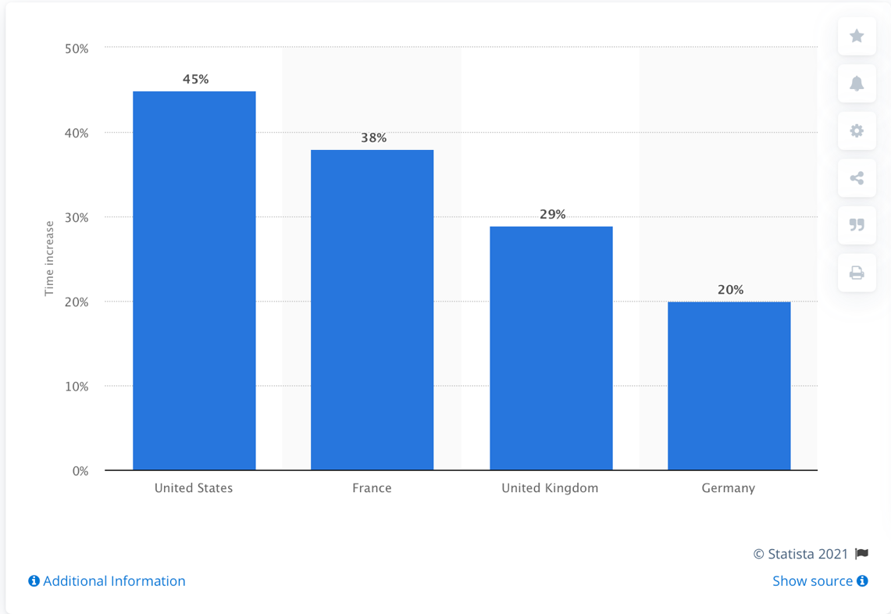

Upon analysing the data, we can see that the US has experienced a 45% increase in the average time spent playing video games, which is nearlyan increase of half, because of this, to be in the business of game development would be a smart decision as its probably the best time to find consumers. This is why I decided to create a survival-based game which runs on wave generated rounds with enemies appearing in greater volumes as the game progresses. The result of this is that the difficulty of the game will gradually increase for the user leading to the game evoking a competitive nature within the player as they will want to see how far they can go and what kind of score they can achieve.

# 2 OVERVIEW

# 2.1 WHY I CODED IT IN JAVA

I decided to use Java as it can be regarded as a programming language that is nearly universally compatible with devices since code is typically run on the JVM, its model can be consistently updated allowing it to stay up to date and compete with newer technologies and is widely used for web based and browser gaming. It’s often paired with HTML for better interactivity and is ideal for object-oriented programming. It is also the language that I am mostly familiar with, having no prior coding experience before attending university and no game development experience until this project I decided to go with the language I’ve used the most while studying other modules. This is so I could apply the knowledge I’ve learnt to my project better and implement good coding practices.

# 2.2 DESIGN INSPIRATION

As discussed briefly in my abstract I decided to define my own take on a ‘classic’ game and took inspiration from games the I grew up on and saw my older brothers grow up on too. The two notable games which I have based my own game off are ‘Box Head’ and the super Nintendo classic ‘The legend of Zelda – A Link to The Past’. Through comparing these originals to my game, it is clear to see similarities in terms of translating the design and feel of these games into my works. Pictured below are two snapshots from Box Head and Links gameplay followed by a snapshot of my project’s gameplay.

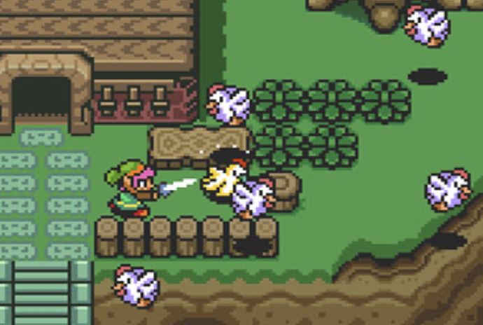

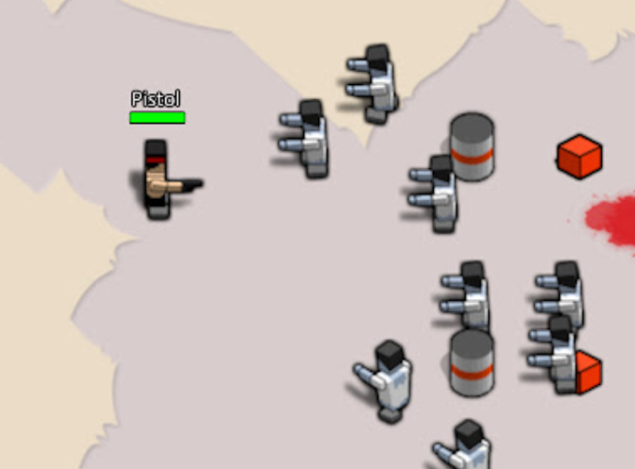

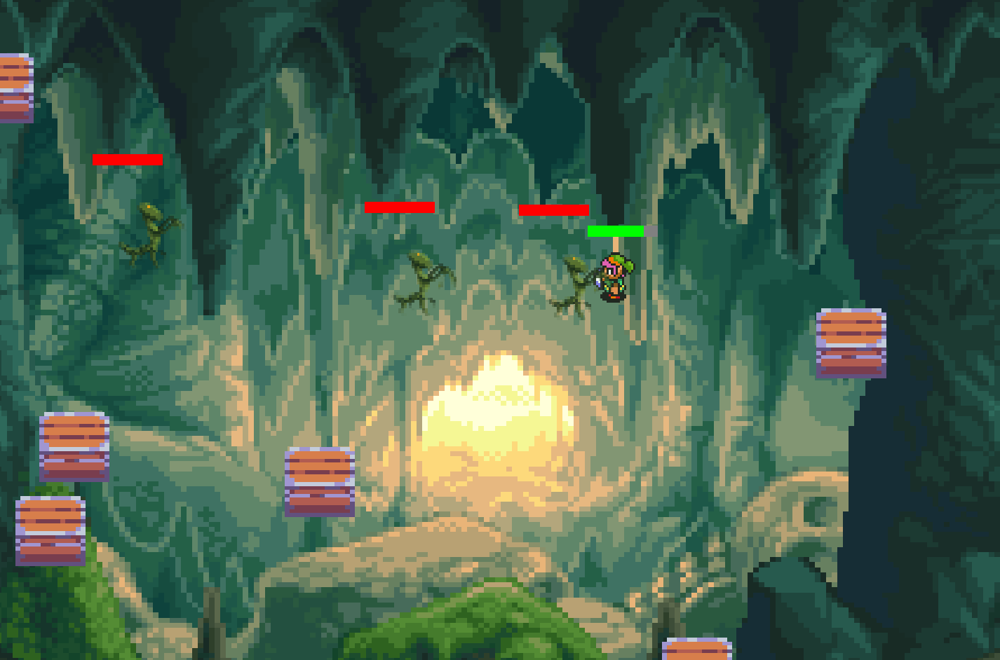

Upon analyzing both games and my own project we can see how I took inspiration from the barrels depicted in the first image and decided to implement my own version of barriers using prop boxes which were then randomly generated upon each run of the game, complete with collision detection to limit the players movement. It can also be seen how I have followed Zelda’s theme of a naturalistic pixel–like layout. I decided to use the main character Link as an element of ‘recreating’ a classic game and used a natural pixellated background as the games backdrop to give it that adventure feel for the user. Similar themes can also be seen with the use of my players and enemy’s health bar. I designed this based off Box Heads health system as seen in the first image, in terms of the mechanics for this system, I will discuss that in more depth in a later section.

# 2.3 BACKGROUND RESEARCH

There has been difficulty finding appropriate background research with regards to my project as understood by my primary supervisor since I have made a game in java which has a sparse number of articles and other sources however, I have endeavoured to discuss the articles which have provided me with useful advice and information to consider when designing and implementing my game which will be expanded on below.

[1] I chose this source to be included as part of my background research due to the fact that this project was the first time I created a game and the article discusses game creation in java which is how I created the game. I am aided by my knowledge of java and the skills I have developed since studying programming and computer science. The source discussed knowledge that was useful to know before starting the creation of the game such as using exceptions, I/O streams, framework and OOP which I had some practice with last year as part of my Application Programming module. Further into the article it also discusses the importance of using GIT as a project management tool to track and update my code especially if I’m working on different workstations so this source material was as relevant to my project as can be.

[2] I found the article exceptionally helpful as it details the very start to finish process of game design and creation. Reading this allowed me to consider the design procedure of my game early on which helped increase its quality of play such as the audience that the game will be targeted at as well as the storyline and even aspects I hadn’t fully considered. This includes its potential for monetization (which could be through pop-up ads) which is arguably the most important factor when creating a game. Reading the article allowed me to realize the scope of my game and other areas such as ‘developing early visuals and sketches’ [of my game in order to get the look and feel of it. Since reading this article from when I had started my project I ended up raising this as a ticket within Jira as ‘create prelim sketches’ so I could have something to refer back to when developing my project.

I have also come to the understanding that game creation isn’t just about implementing but thorough planning and documentation which includes designing “GDD’s” which stands for game design document. This essentially maps out the vision for the project including the story and game characters, rules and mechanics however this document is fluid throughout the project and is tweaked as the game is adjusted. Similarly managing the project in Jira also embodies a similar principle of GDD’s so I stuck to using that system to realise my project as it progressed. The source also continues to discuss further stages of development however some areas aren’t quite applicable as the article discusses the stages of development for teams of creators rather than creation from an individual person. So it was important to only acknowledge what was relevant to me otherwise I may have developed an extensive workload that I wouldn’t be able to manage.

[3] This particular article was helpful due to the fact that when it comes to using animations within the game for the characters, the movements need to appear fluid and smooth. This source explores a few ways that animations can be created within the game using java.

One of them, interestingly enough discussed utilising gif images and putting it on to a sprite sheet in order to simulate fluid movement, I found this useful as when implementing the action animations within my project I had considered using it, the example they used was moving a starfish [3] to simulate a fluid motion but more interestingly the article continues to talk about other methods of animating. I didn’t decide to use gifs to animate my sprites on the basis that it can take up more storage to store a gif in a game than just a static sprite sheet. Reading about the use of coordinates in java graphics and the draw image method has helped me getter a better idea of how to implement my sprites as it allowed me to look in to animating images using frame by frame transitions and then looping through them using an iterator while using a timer to give it a smoother look which I ended up using for my attack mechanisms.

# 3 GAME DESIGN

# 3.1 PLANNING & THE DESIGN PROCESS

Before I had done any of the implementation for the code, I decided it’d be best to approach the project first by conceptualising some designs and also consider the requirements and planning of the project. In order to consider the planning and requirements of the project I needed to understand the full scope of the projects and the iterations of the design cycle in order to build a successful project. Upon doing some research I came across an online article with some useful information about the game development process which was discussed in an earlier section.This included developing early sketches of how I would want the game to look and feel.

This resulted in the creation of a rough draft of my first iteration of designing the game, here a link is provided where the sketch is available to see on Jira [A301423-6](https://cseejira.essex.ac.uk/browse/A301423-6). Looking at this early iteration its clear to see my initial idea was to have a menu system where the gameplay could be initiated alongside viewing other parts of the systems such as controls etc. then upon playing the game the player would go through a series of differently designed levels and enemies with obstacles to restrict the players movement and other props which could inflict damage. The attack mechanism I had conceptualised at the time was also a projectile.

I soon realised upon creating the design the implementing the code and mechanics for this design would be far too complex as the level graphics would need to be redrawn with their own custom layouts and obstacles for the player as well as projectiles having to be implemented for the enemies and it was not feasible to have completed in time for the project’s deadline considering the workload I would be dealing with in other projects for the year. I also had to be critical with my design and decided that the best thing to do is to stick to creating a classic themed game. The game should be easy to grasp, not too complex yet provide a fun and challenging gaming experience.

# 3.2 GAME ASSETS

I then had to consider what type of aesthetic I wanted the player to have for my game. I was aware that it needed to have a retro and colourful look. I did a lot of research looking at free and open licensed assets that I could use as sprites. There were several times I had thought I found suitable sprites that I could use as a player but a lot of them were missing key movements, were poorly created or were simply not fitting for the old school theme I wanted to embody.

The result of these issues led me to using Adobe Photoshop software to develop my own custom sprites. I had never even used the software until this project but had heard a lot about the software in the graphic design industry and decided to look up some tutorials and walk throughs to get to grips with the basic knowledge id need to craft my own sprite sheets. I had eventually decided that the Super Nintendo version of Link would be a perfect fit as a player for my game so I tried to find a set of sprites I could use for my game however I faced the same problems as described above. Since the game was a classic it was difficult to find useful sprites and when I did find PNG’s they were so poorly made in terms of formatting and the way in which the frames are animated and would require some tweaking here and there to make the frames look smoother. I ended up finding a rough set of sprites I could go off [4] and decided to re-craft the sprites in my own sprite sheet in Photoshop, tweaking some movements and reformatting them so they were readable by my sprite sheet loader program.

# 3.3 GRAPHIC DESIGN

Pictured below is a screenshot of me using the photo editing software to create my own sprite sheet. I started by applying vertical and horizontal grid layout on a PSD as PNGs are not editable on the software. The reason for applying the grid on the sheet as a layer was so that when I was adding in the frame animations in, I could make sure they are all in line and fit comfortably in their area so when the animations are iterated through it doesn’t look uneven. I used the few sprite movements I had and shifted their frames and copied them along the row so they could be animated by the java code. I kept the movements sectioned into their own rows so that when their referenced the X starting point would always be 0 and the Y would be changed for referencing the start of each animation. I used the lasso tool and smart object selector to cut the sprites out from the original sheet and carried them over to my custom layout.

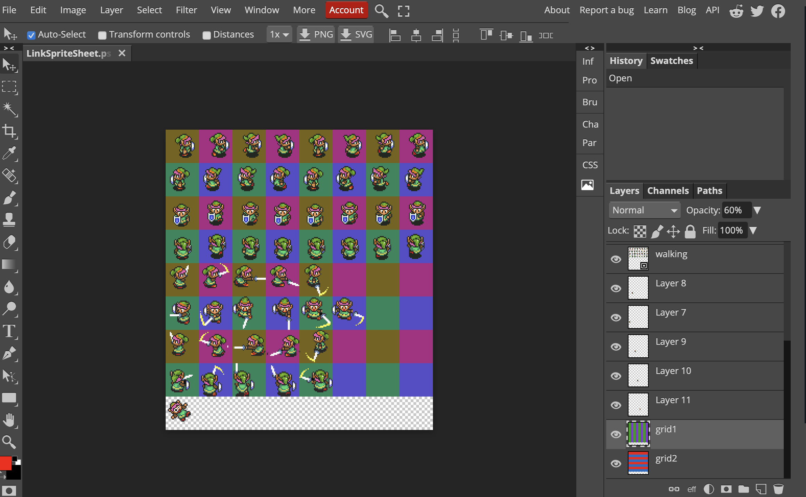

Below is a screenshot of the first iteration of my game where I had first animated the player and was still implementing the mechanics for the collision detection on my props. Interestingly enough I had intended to use a rock image as the obstacles for the game but as you can see from the debugging below, I had a lot of difficulty figuring out how to trim around the rock shapes as they didn’t even sides all over. If I had stuck with this, the collision would’ve been rectangular and would stop the players movement where it shouldn’t.

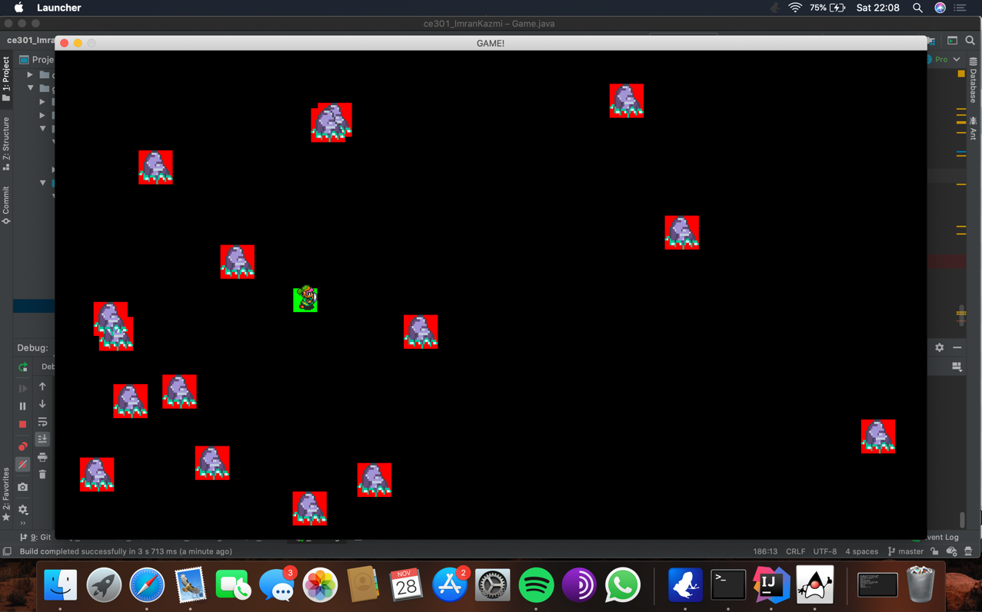

The effect of this was that I decided to use a different asset as a prop which was a lot easier to use for detection and also fit with the overall design theme better in my opinion. Below you can see the box prop implemented and being used as barriers to restrict players movement.

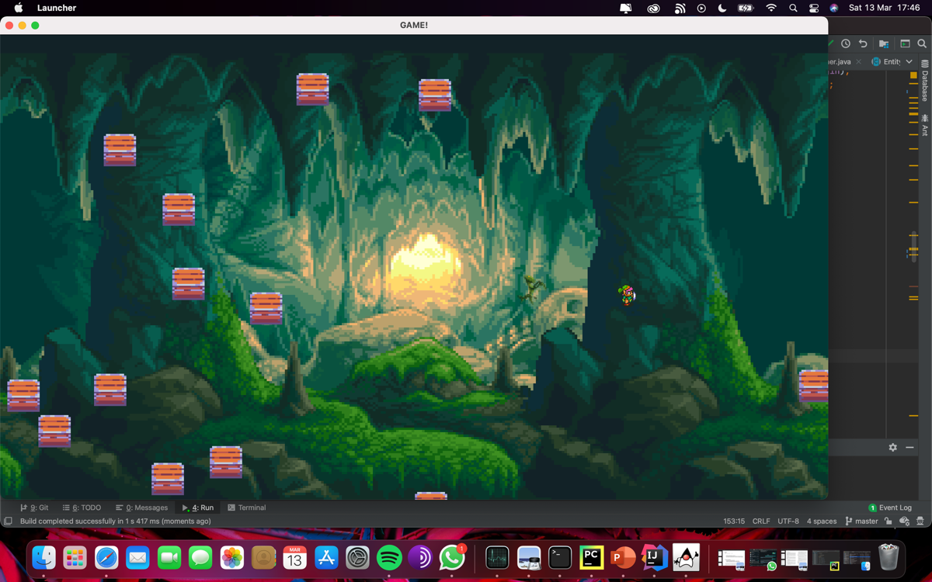

After creating my player in photoshop I realised it can make the design process much easier if I do it myself as I can make them as I intend and layout the animations in a more organised way for when they need to be referenced. Upon doing some further research in to what enemies I wanted to implement I came across a lot of potentials. Ultimately, I found an asset pack which suited my needs perfectly. They used free asset packs which were submitted by the creator where the choice to pay for it was up to the visitor, I managed to find an insect asset pack complete with attack and movement animation. The result of this was that I decided to utilise the Mantis asset as my main enemy for the game and the Beetle asset for the boss enemy with higher hit points.

I then took the animations and placed them in a custom grid and laid them out as I wanted to. I then additionally edited death states for my Mantis as the pack didn’t come with one so split one of my animations in two parts to make it look as if the enemy died when the player split it in half with its sword. I then exported the three PSD’s as PNGs for my game and implemented them in the code for my game development [5]. [A301423-37](https://cseejira.essex.ac.uk/browse/A301423-37)/[A301423-46](https://cseejira.essex.ac.uk/browse/A301423-46)

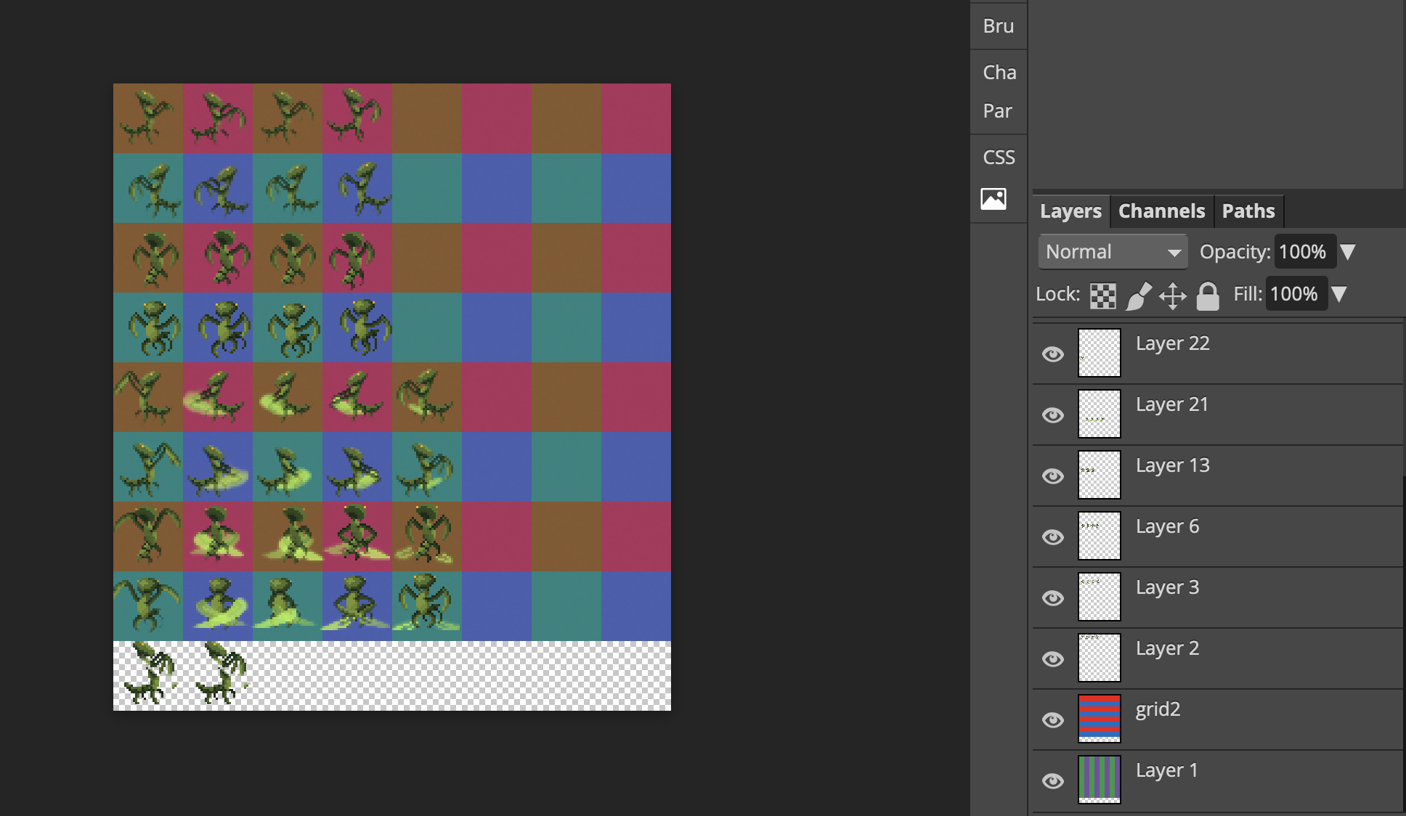

Here is the original download of the asset pack:

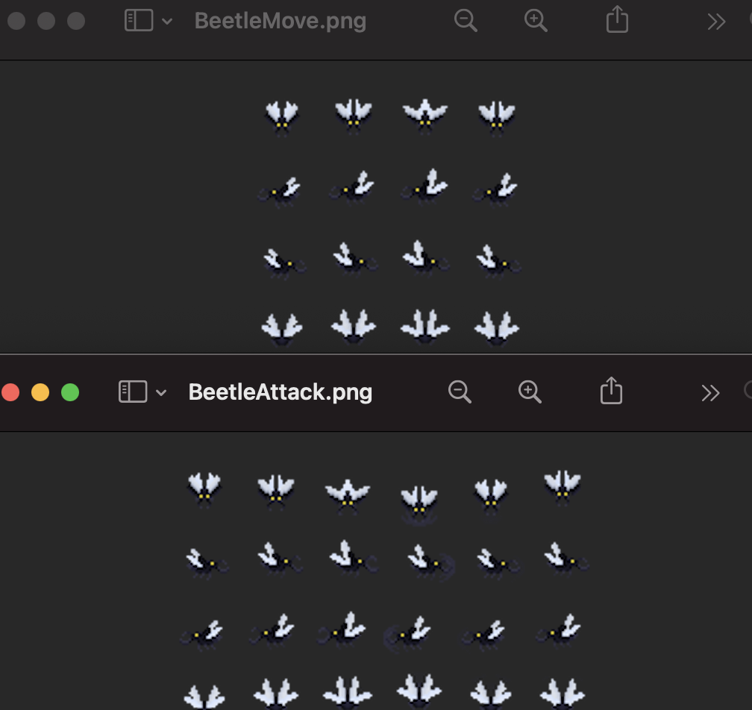

Here is the sprite sheet I created to put the animations in to one:

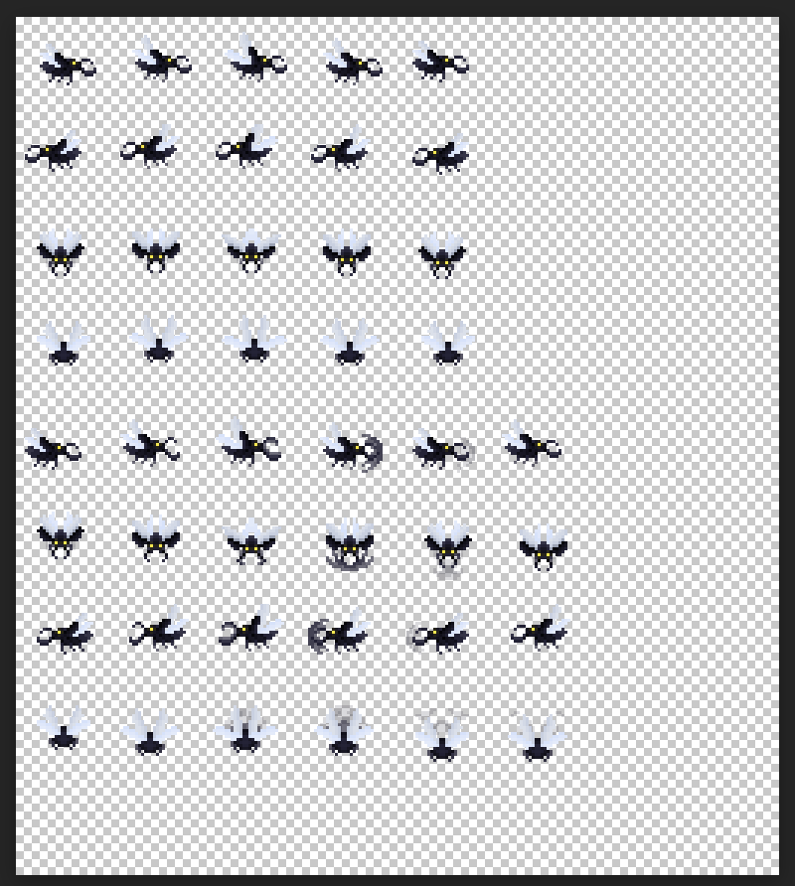

# 3.4 MENU SYSTEM

I also created the menu system using an image background and painted it on to a panel I created for the menu. The menu extends JFrame and implements action listeners so the user can navigate the menu. I believe the menu reflects an RPG inspired game, I personally would say the likeness is similar to the global RPG classic ‘RuneScape’ with the colour scheme used and decided to keep the menu sequence very simple and straightforward to use as a simplistic classic game would.

In the image shown below we can see the menu backdrop is a cave like background; this relates to the main games backdrop which is a cave where the player kills enemies. The menu system has a corpse which I’ve used to represent a dead enemy and it creates an eerie setting for the user which should invoke a sense of unease to prepare the player for the intense gameplay ahead. All buttons on the menu work and the controls button opens an additional screen which explains which controls are used to control the players movement and attack. [301423-10](https://cseejira.essex.ac.uk/browse/A301423-10)

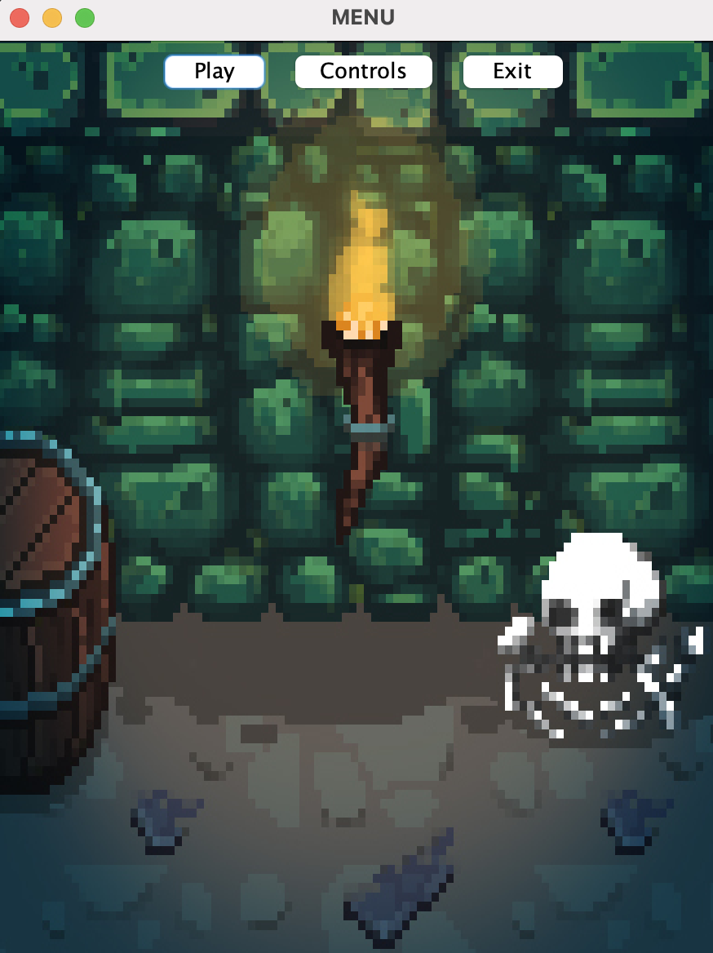

Pictured below is what pops up when the user presses the ‘Controls’ button. In this screen we can see a simplistic layout which an adult or child from any country would be able to understand. I create the WASD & Arrow Key images in paint and transferred them in to photoshop to put on my backdrop. The player animation above the keys also explains what each set out keys do as the game uses 2 sets. I decided to use two sets of keys for a particular reason. This is because its similar to how classic arcade games would have a joystick and a few sets of buttons to play with, this causes the player to feel more immersed in the game as they are using both their hands to engage in the game.

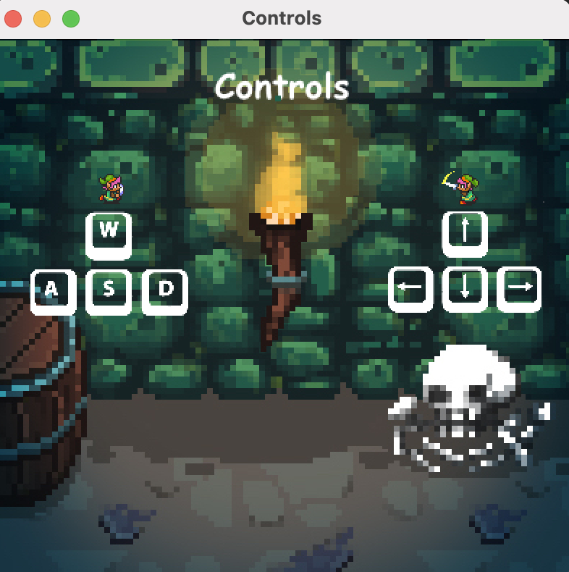

# 3.5 GAMEPLAY

The following screen shots are taken from gameplay of the game and show the player fighting against the generated enemies. Within the image we can see the score counter in the top left and the wave counter in top right of the game. It is also visible to see the player who has taken damage and the enemies, some of whom have also taken damage. It can also be noted that the screenshot catches mid frame one of the enemy attacks towards the player which will deal further damage.

As discussed earlier in the report we can note the design of the health bar system for both player and enemy. These were made to reference the same look and feel as the classic game ‘Box Head’ pictured earlier in the report and strongly reflects that classic arcade feel. I use a green health bar for the player and a red for the enemy so it’s clear to distinguish which health bar belongs to which entity. If the player had remained alive until wave 5, they would have received a health increase and the green bar would have increased in size. This encourages the player to keep playing and gives them some help to continue the game if they have a low amount of health. If the player has maximum health already, they get awarded additional health if they make it to every 5th round but once they lose that through damage the normal health bar is displayed.

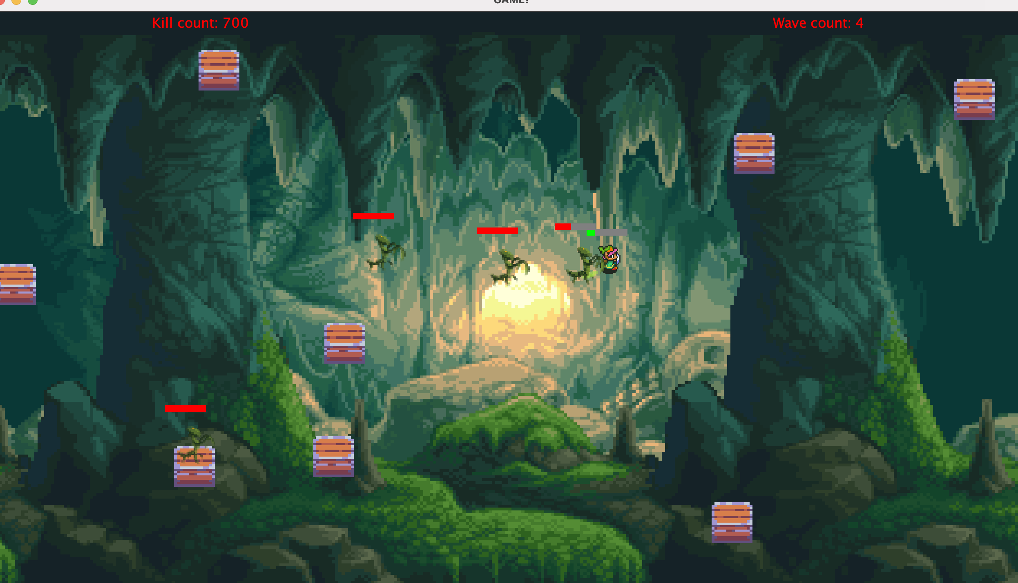

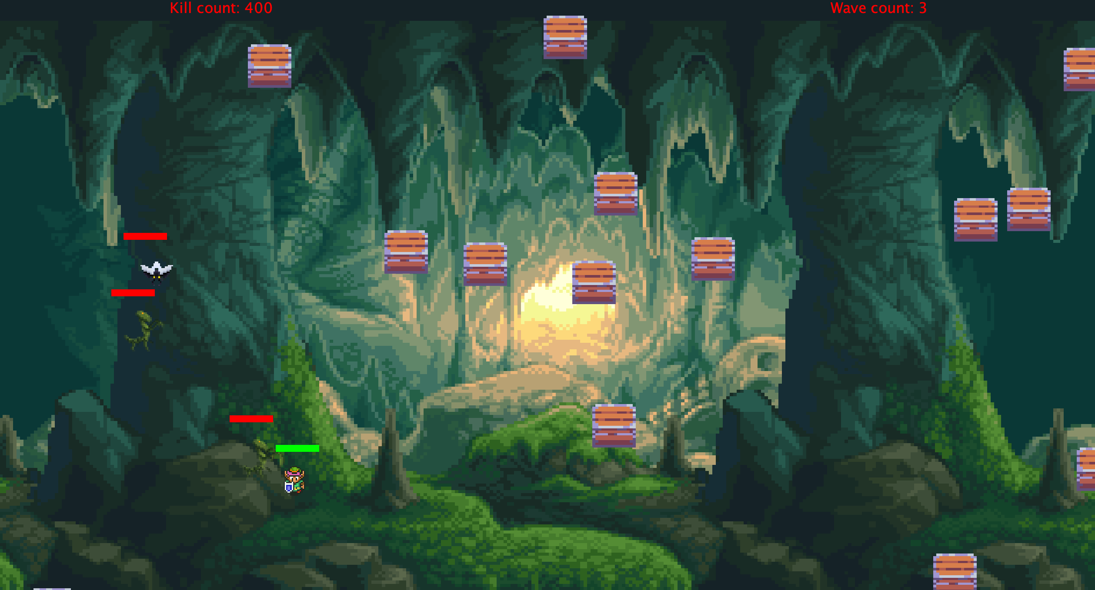

The next screenshot shows the player who has been defeated by the enemies as he no longer has any health left. The controls are disabled, and the players death animation is shown with a message above the player notifying them of what has happened. The score and wave counter are enlarged upon death to highlight to the user their statistics so they can reflect on how well they did in this instance.

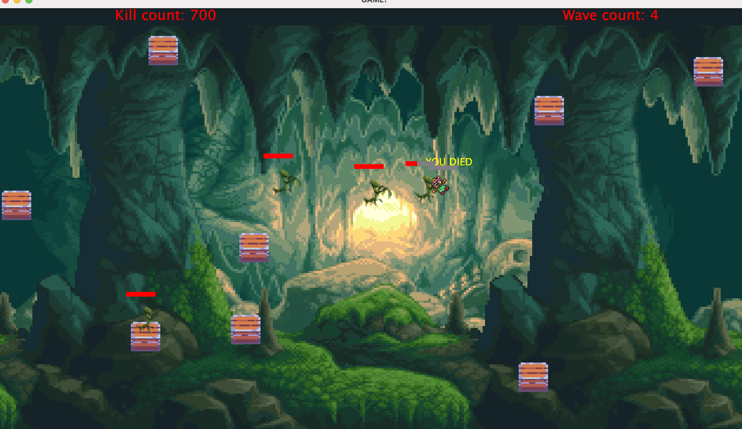

# 4 GAME IMPLEMENTATION

# PACKAGE DIAGRAM

|  |  |  |  |
| --- | --- | --- | --- |
| Package : Core | Package : Entity | Package : Sprite | Package : Util |
| ControlsFrame | Entity | SpriteSheet | AnimationTimer |
| Game | Enemy |  | AssetManager |
| GameFrame | Beetle |  | KeyHandler |
| MenuControl(interface) | Mantis |  | Menu |
|  | Player |  | Renderable |
|  | Prop |  | Values |
|  |  |  | Vector2f |
|  |  |  | Launcher |
|  |  |  | PlayerControl(Interface) |

# 4.1 GAME MECHANICS & FEATURES

* RPG style menu system
* Collision detection
* Randomly generated obstacles
* Custom sprite frame creation
* Animated sprite movement
* Timer to animate player attacking smoothly
* WASD X Arrow key movement for player
* Automated enemy path finding system
* Attack systems utilizing threading
* Health bar damage system
* Periodical health regeneration
* Wave counter system with automatic spawning
* Score tracking system
* Range detection for automated enemy attacking
* Enemy boss levels
* Death animations for enemies

# 4.2 WHERE I STARTED THE IMPLEMENTATION

When I began starting to write code to implement in the game the main aim was to write code that is dynamic, reusable, clean and implements good coding practices.

The first point of implementing the design was to load the sprites into the game. This was done after the basic creation of the JFrame and panel. For this to happen I created an asset manager class ‘AssetManager’ which uses a HashMap to store two types of data to be used. The first being an integer value which referenced my Values class, so I know which direction the sprite needs to access, and the second value is a reference for the sprite sheet class ‘SpriteSheet’ which controls which sprites to read in a sheet using a sprite array of X and Y values to retrieve the animations in each row and column. Within class ‘Values’ are references of the sprite sheets directions; up, down, left, right and an integer reference for the three different sprite sheets that are used in the game. This enabled me to use cleaner code within my game class and allows the code to be easier to understand when another programmer is reading it.

Below we can see the sprites being loaded into the game where sprites are being accessed through the asset manager and the values assigned to them.

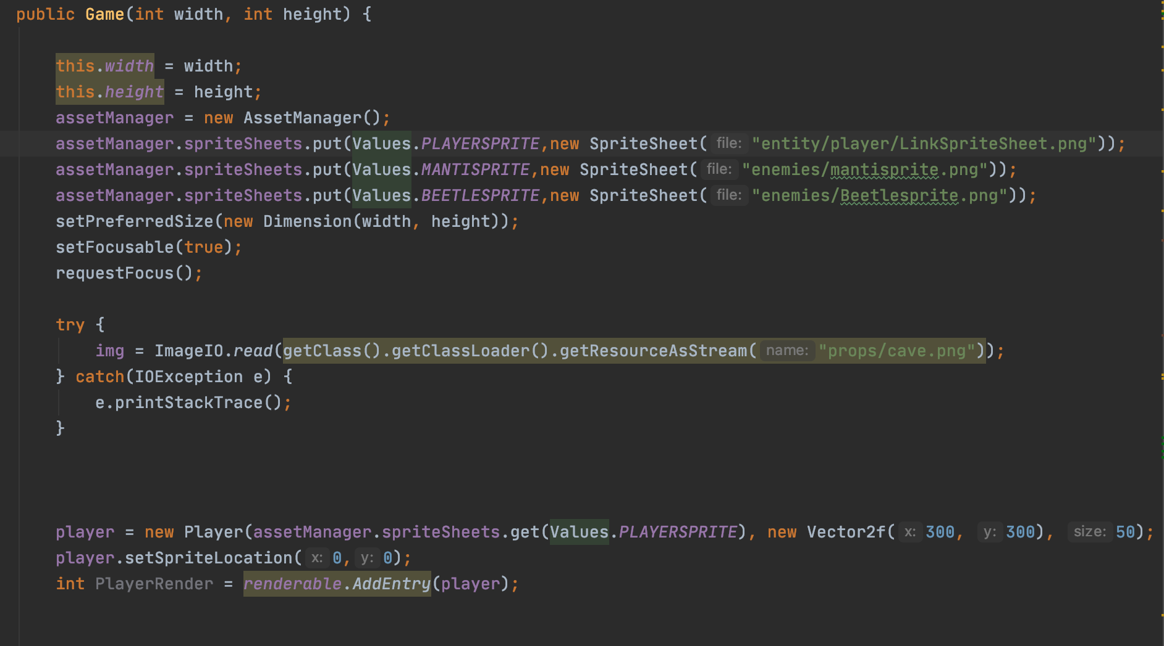

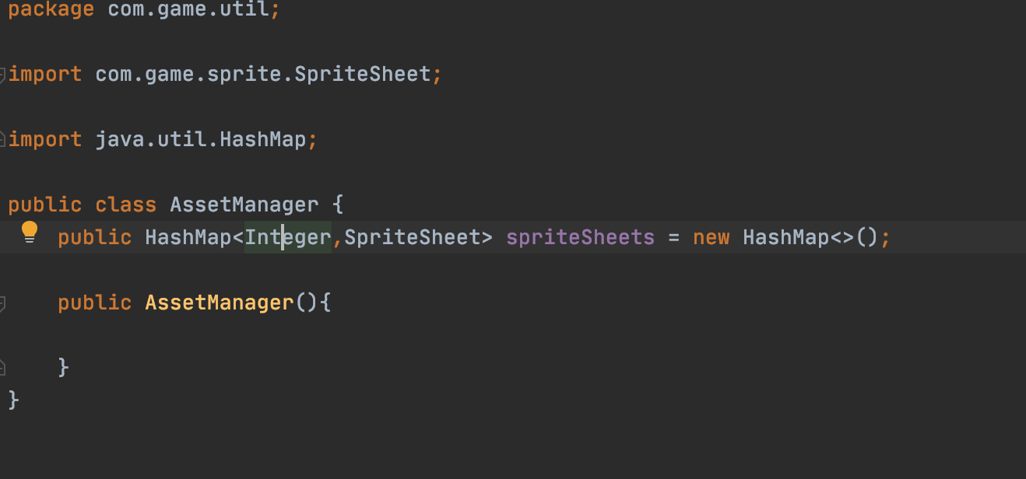

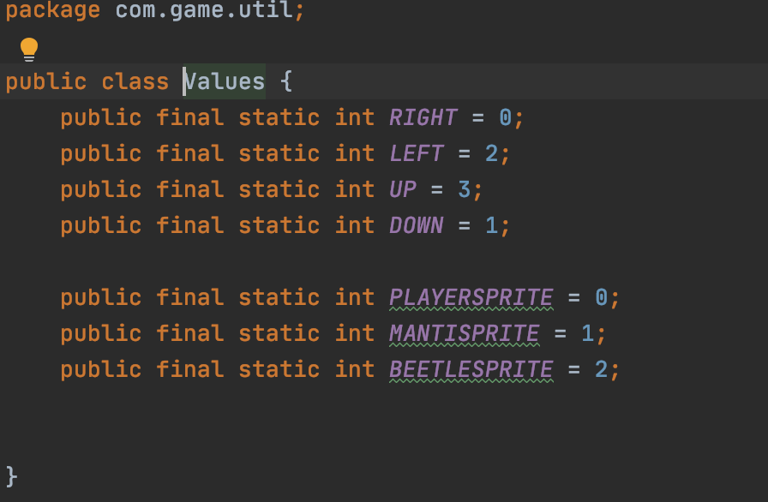

# 4.3 SPRITESHEET LOADER

Below is a screenshot of the class SpriteSheet. Here we can see the main elements of the class include setting out the tile size of the sprite sheet, this is important because the grid used for the animations uses the measurement of 32 pixels. The load sprite method uses the file path supplied when reading the spread sheet and uses error handling in the event that an incorrect file path is provided. The loadSpriteArray() class then increments through the x and y of the sprite sheet and reads each image in the sprite sheet as a sub image. (Jira ticket link) [A301423-8](https://cseejira.essex.ac.uk/browse/A301423-8)

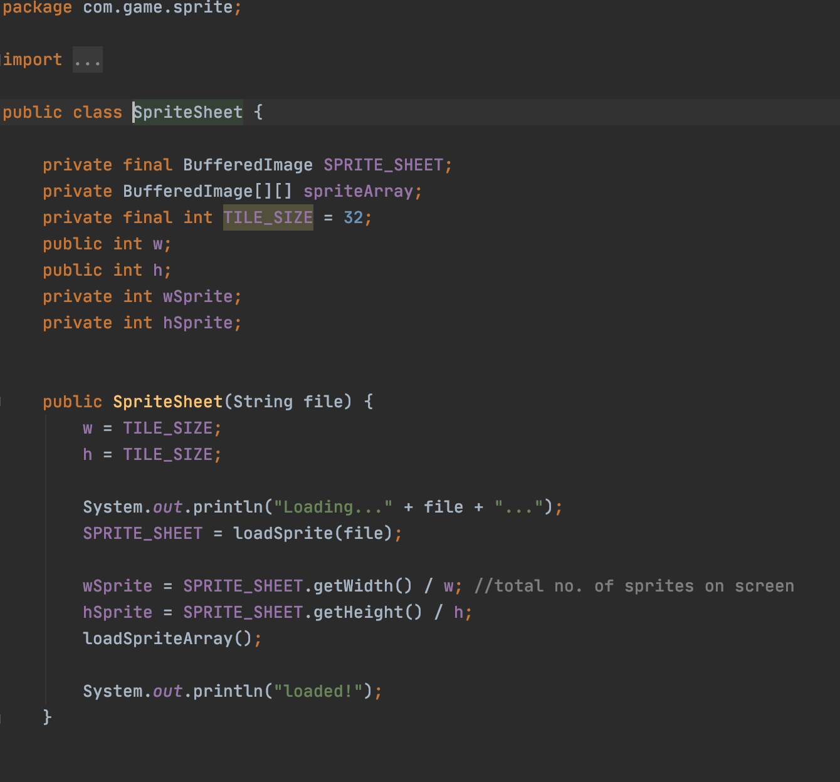

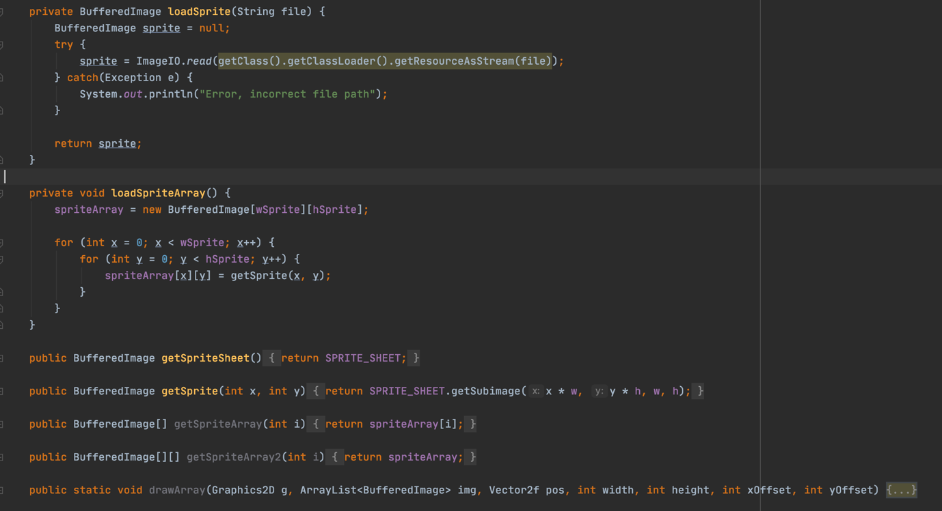

# 4.4 RENDERING SPRITES

Thinking logically from this point I decided it would be best to create a class to render the sprites that are getting read. This was fairly straightforward as all it required was an array list that extended the entity object so the attributes of that class could be accessed. Once that was created, I created a method to add entries into the list and then iterated through the size of the list and called the render graphic for each item. I made sure to only do this if the list is not empty so that there would be no error thrown if the function tried rendering objects from an empty list. See below to view the Renderable class. [A301423-15](https://cseejira.essex.ac.uk/browse/A301423-15)

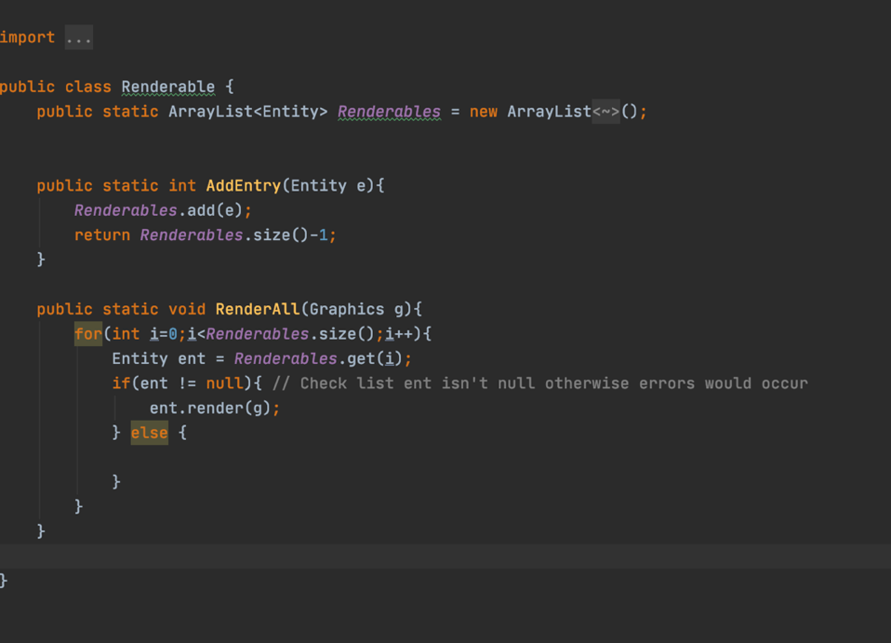

Once the Renderable class was created I was able to use both the assetManager and the loaded sprites from spriteSheet to create my enemies and players easily in Game class (extends Gameframe) where the code would be run.

It is also important to note here that the enemies are all stored in an array list of enemies which made it easier to render items and to also render them out when necessary, for example when they die, they are simply removed from the list after an animation is run.

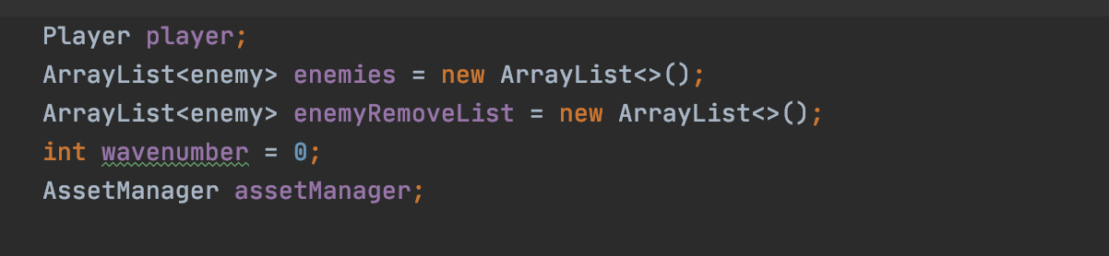

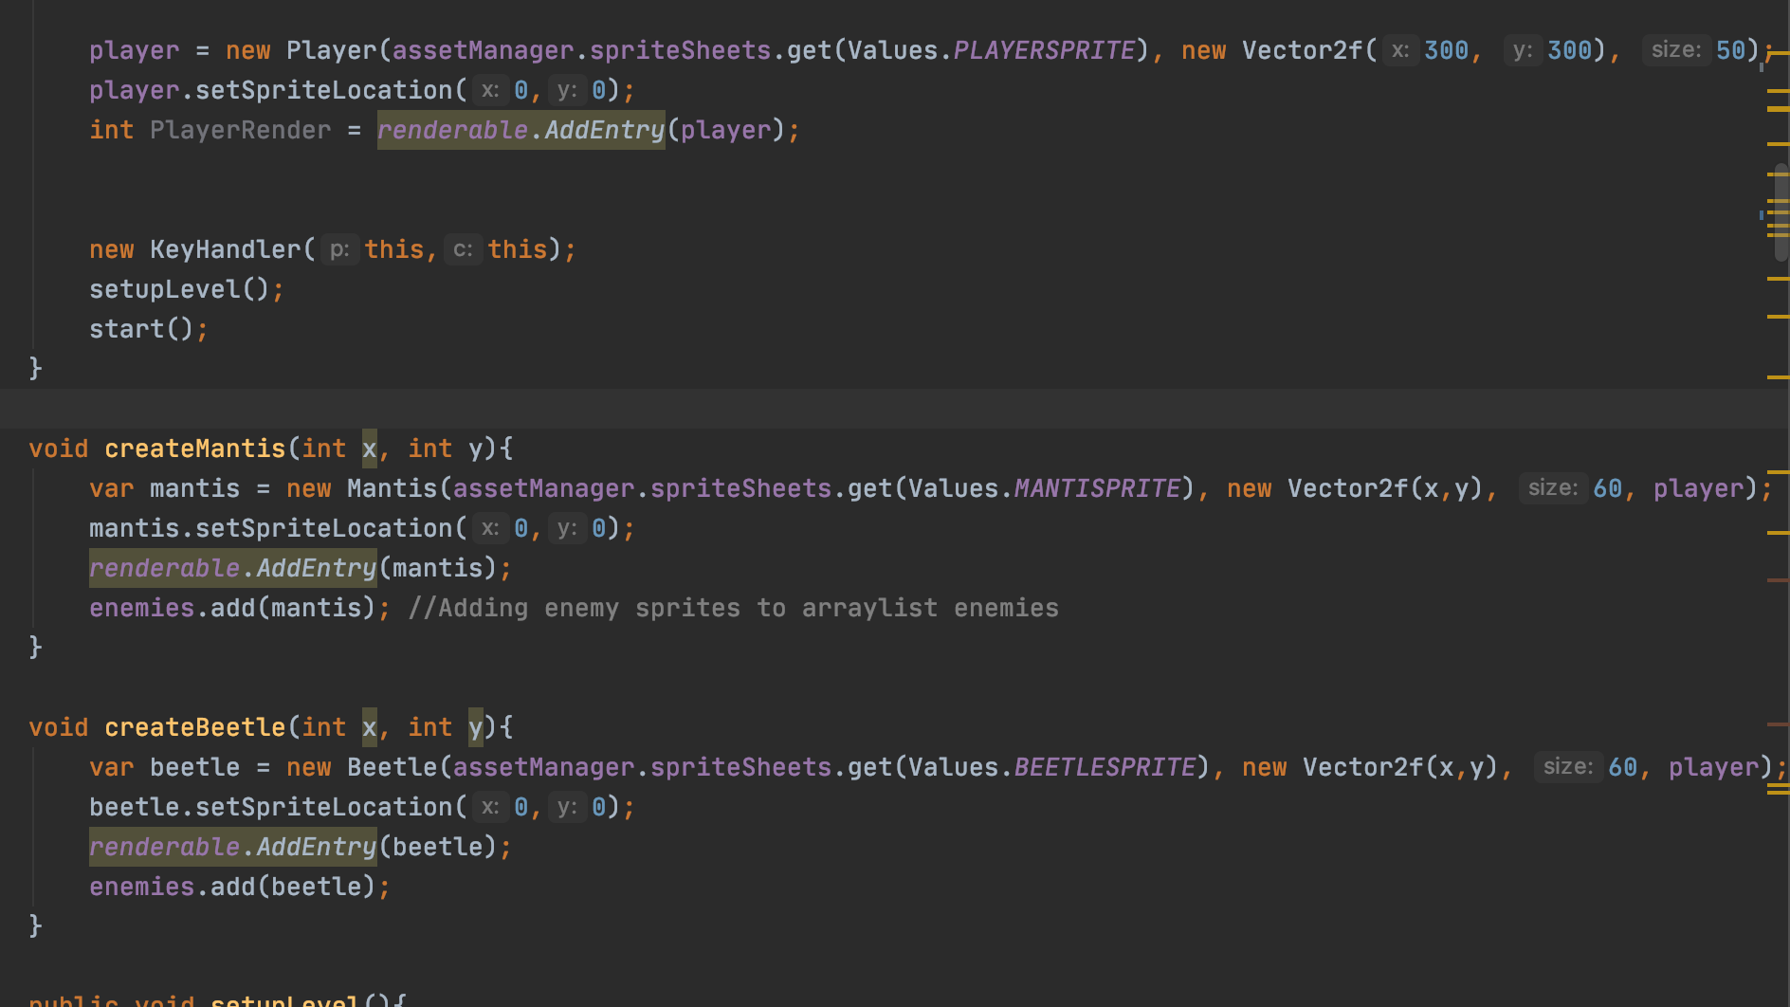

# 4.5 MANAGING ENTITIES

After the player had been rendered, I decided that a class would be needed that holds references to the states an entity would be in and methods that all players and enemies would need to use. Because of this I decided to create an entity class ‘Entity’. Within this class is positional vector values of a sprite including X and Y values and well as X and Y margins so ranges could be established when it came to detection and registering overlaps. Other methods also held within Entity includes the death state to be implemented in all characters which would use the setSpriteLocation() method to reference an animation. Also, a method to obtain the centre of an entity which was useful for using path finding and debugging where it would be necessary to make sure the x and y values are incrementing correctly when the sprites position changes. [A301423-18](https://cseejira.essex.ac.uk/browse/A301423-18)

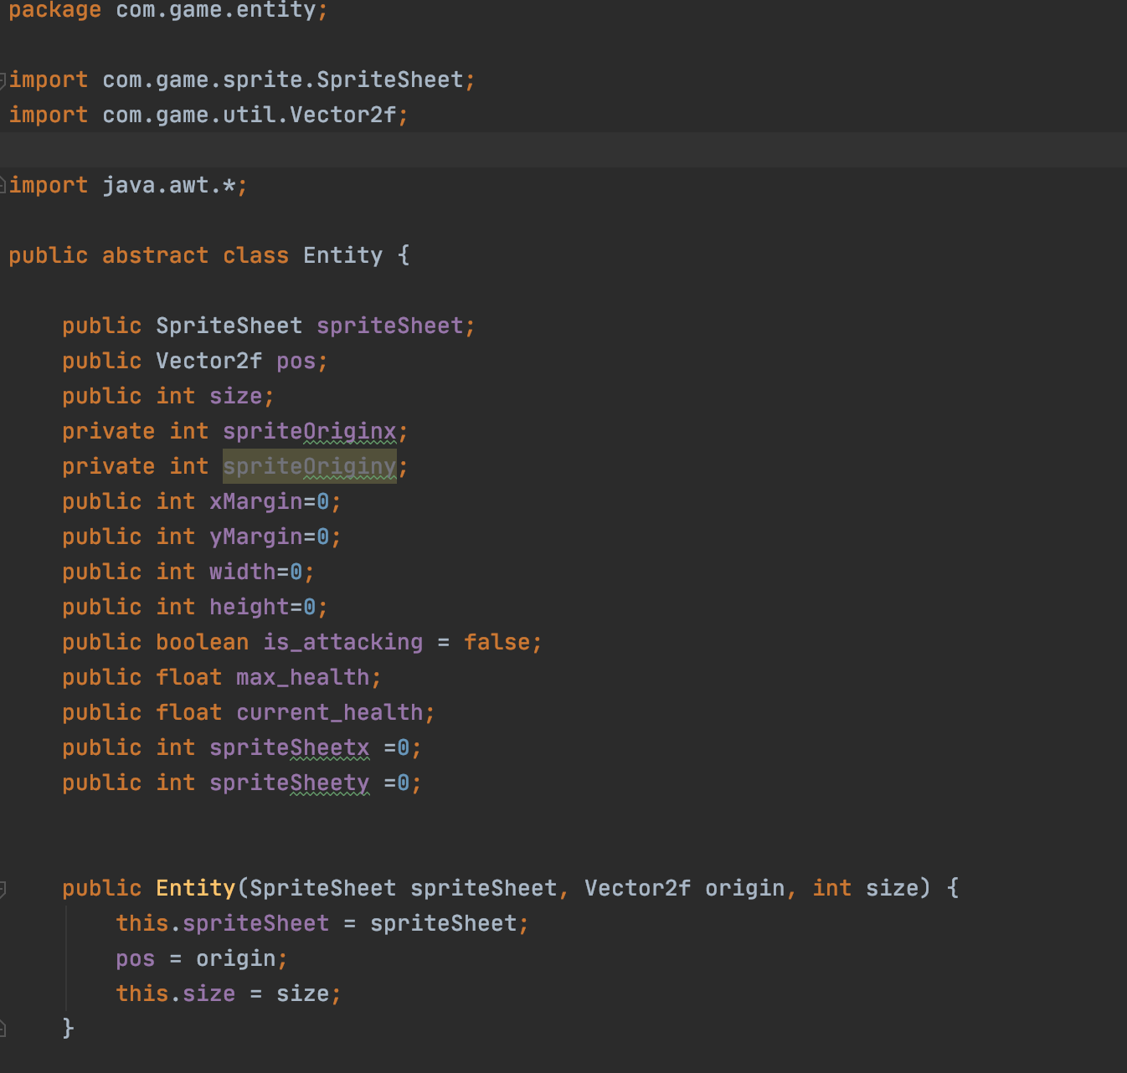

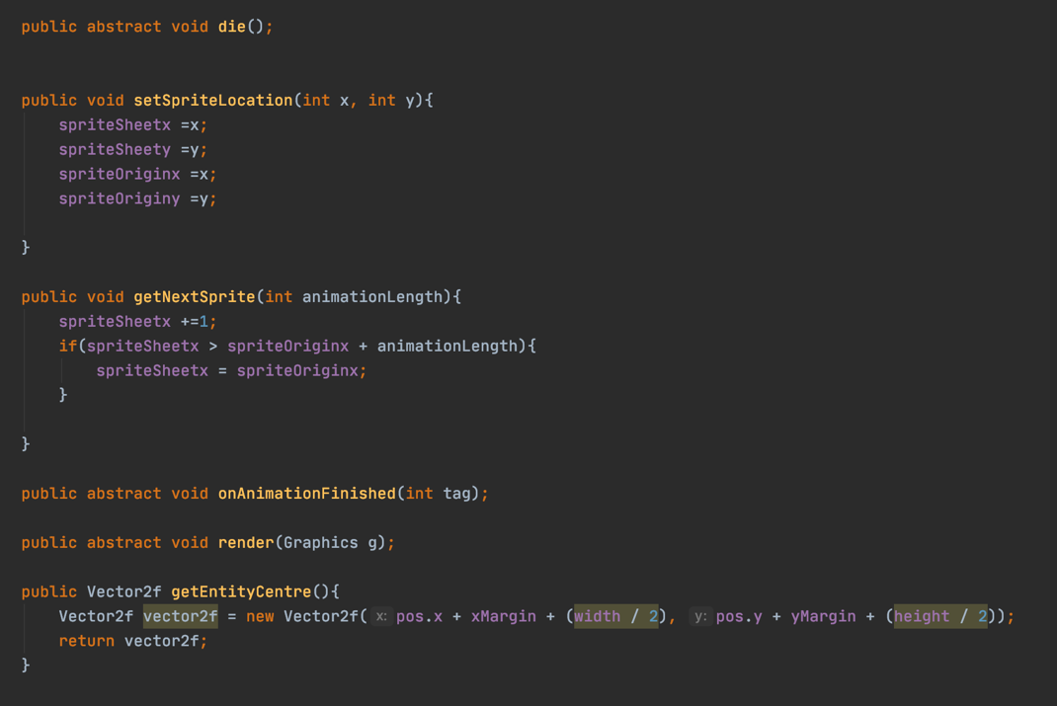

# 4.6 ONANIMATION FINISHED METHOD

The onAnimationFinished() method was especially helpful to use and was needed because when I created the attack sequence of the enemy I used a thread so that the attack animation was a lot smoother since it needed to iterate through frames while other enemies would be rendering and animating at the same time. This meant the processing load on the system would be great.

Using threading was ideal for this since it could run that process separately from the program and therefore would execute at a quicker speed as it wouldn’t need to process all the other code first. The attack animation was done using the AnimationTimer class which I will discuss in more detail when it comes to discussing the attack mechanism. This lead to an issue where upon attacking, because it was running on a thread the timer would run and the attack sequence would happen so quick that the player wouldn’t get a opportunity to fight back before he is killed due to the attack taking place every time the enemy registers the player near it. This meant the game wouldn’t be reasonable to play.

To fix this issue I decided to implement the onAnimationFinished method which would place an attack delay after every attack animation has finished running. The was done by using Thread.sleep followed by a millisecond parameter for how long the thread would stop running for. By placing a 2000 milisecond delay on the attack it allowed the player to be able to get away or avoid the attack after the first attack had been executed since there would be a small pause between each attack but a very important pause since it also gives the user the opportunity to attack the enemy back before he is killed.

Below the implementation of this method can be seen from the Mantis class which is an enemy sprite. This was implemented on all enemies since they use threads to attack.

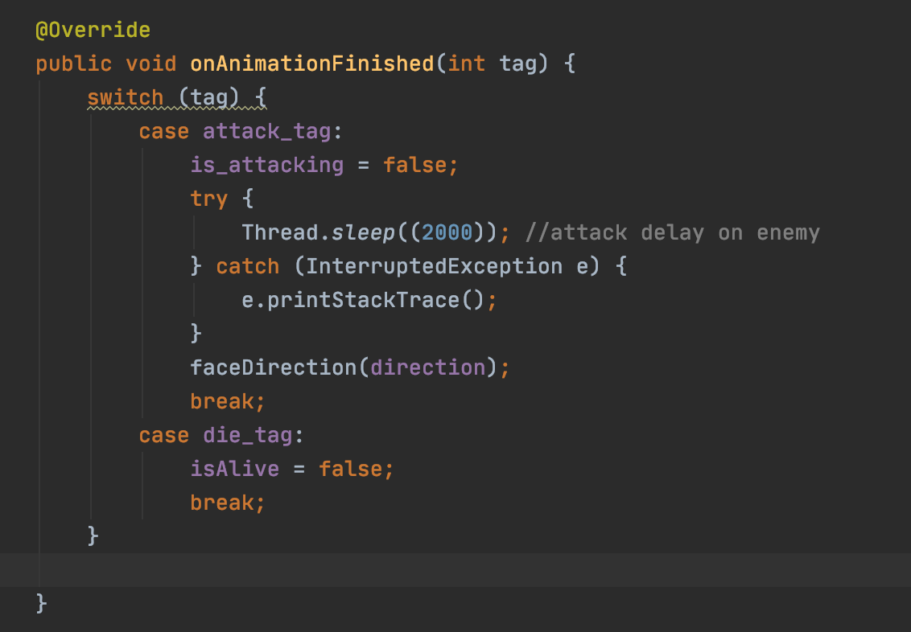

Once this class was established I was able to have all the classes relating to the sprites extend Entity and therefore they could access all the methods within Entity which made it a lot easier to implement the different states and kept the code organised across the different classes. Both the Player() and Enemy() class extends Entity and the methods and attributes within entity are inherited from the subclasses.

# 4.7 PLAYER ATTACKING MECHANISM

Within the Player class there are attributes specific to itself also such as the frame rate at which the animation moves at, this is set to 10 so when the player is moving it still gives off that classic pixelated movement of frames between iterating frames. It also holds attack states and the range at which the player is able to attack at, this is used with vector values to determine the distance between two points, if the player is attacking and the range is within the bounds set then the enemy will register the attack and take damage.

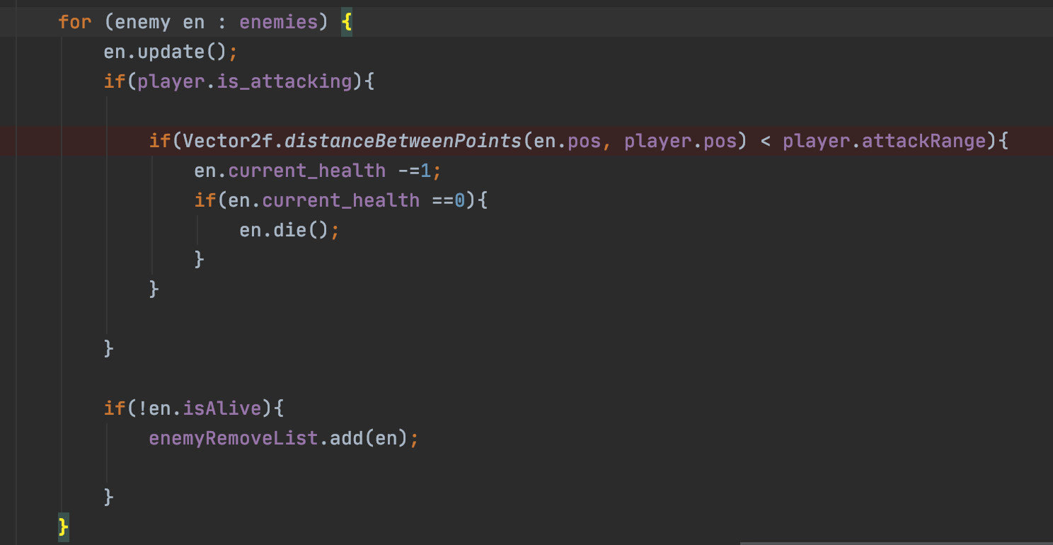

The same methods from the Entity class along with a few additional methods such as directional values referencing sprite frames and the directional values for the attack animation frames are also in Player().

The class contains code regarding the frame rate at which the sword attacking animation from the player runs at, this had to be set for the same reasons as the attack delay on the enemy as described previously. Before creating the frame rate for the thread the attack would happen to quick and the user would be able to spam the key leading to a super speed of attacks which wouldn’t be implementing good gaming practices so I slowed the frame rate down to 24 frames for a smoother and controlled animation.

# 4.8 KEY HANDLERS & DIRECTIONAL MOVEMENT

Pictured below is a screenshot of the Key handlers being made for the players attack and directional movement, this is then referenced in the Game class so the player is able to face the correct direction and the movement of X and Y is contained in the Vector class. I passed int direction as a parameter as I used an interface. Interfaces can only have abstract variables and no method bodies within the interface, it also allowed me to achieve multiple inheritance as I knew I would use this across my program for directional values for both attacking and movement. I used this to work with my Keyhandler as I declared variable ‘c’ as type interface as seen in the screenshots below. I also added in two conditions within my move() and canMove() methods which dictates that if the players health is equal to 0 then a return statement is called making the user unable to access the key movements as they are dead. [A301423-11](https://cseejira.essex.ac.uk/browse/A301423-11)

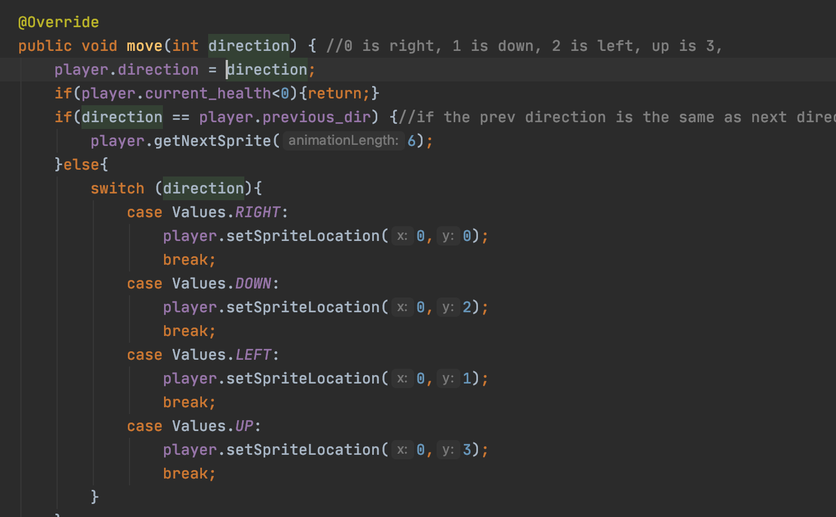

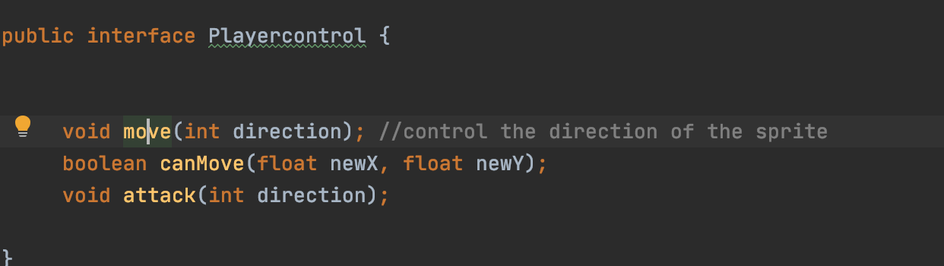

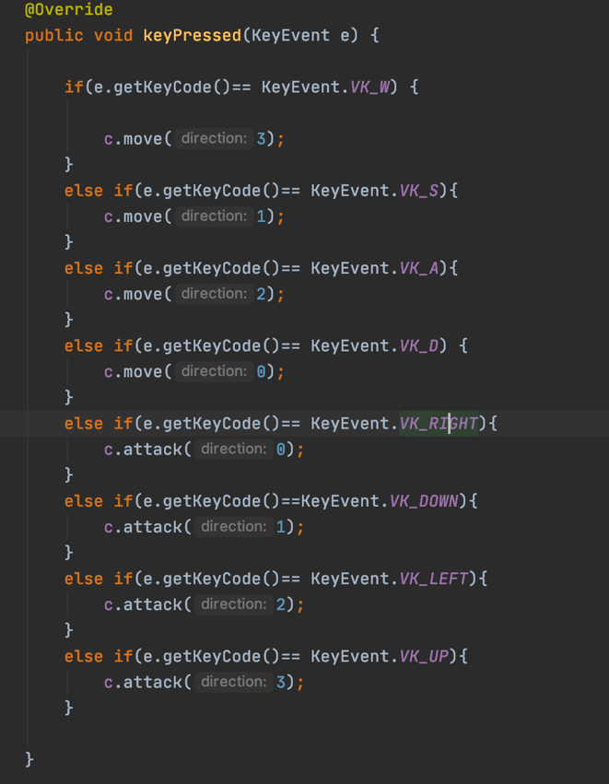

[A301423-23](https://cseejira.essex.ac.uk/browse/A301423-23)

# 4.9 ENEMY MECHANICS

The Enemy class holds similar methods and attributes to the above classes with the difference being the enemy class is extended by subclasses due to there being more than one type of enemy rather than only one player. The result of this is that additional information such as the attack range an enemy has and the amount of damage every attack inflicts, with different enemies the damage it takes to kill an enemy varies but all enemies will inflict the same damage on the player.

Notable methods also include range detection for attacks which take the players position and compares in to the attack range value, if it is in range then the the player must be getting attacked and this will be registered therefore causing the player to take damage and decrementing its health. This will be elaborated upon further when discussing the health bar implementation. Vectors are also used to update the enemies position in order to make sure its facing the correct angle when attacking the player, and this will be discussed in more depth when explaining the enemy sprite classes Mantis() and Beetle().

# 4.10 PATHFINDING

As mentioned earlier when discussing the rendering of entities, the Mantis and Beetle sprites are stored in an array list making it easier to add or remove items where needed. Both these classes are set up the same with a few minor differences, these include the maximum health an enemy can have as well as a speed variation mechanism. This was implemented because the Mantis sprite is the most commonly used enemy in the game with it being generated in every wave. Due to this and the way the path finding is coded, I found that more often than not the enemies can end up clustered as they all head to one point, the players centre position. After thinking about how I could solve this issue I had two choices.

The first was to remake the path finding method so that it implements some artificial intelligence elements, because of this I decided to look in to Dijkstra’s algorithm for path finding but after some time I wasn’t able to get to grips with the inner works of the code so I decided to think about alternatives. [A301423-38](https://cseejira.essex.ac.uk/browse/A301423-38)

I then arrived at the second option which was to add an element of speed variation randomly amongst the difference Mantis sprites that would be generated. I did this by using the Random() function generator which generates distinct values, then I used random.nextFloat() which returns the next pseudorandom number and subtracted that by 0.5 and multiplied the result by 2. From there I created a variable called variation and set it to 0.5 and multiplied it by the speed of the sprite which was set in the Enemy class. Finally, I reassigned speed so that it was equal to speed + variation * rand so that every time a new enemy is generated it will have a distinct speed stopping the enemies from clustering over each other when making its way to the player. [A301423-52](https://cseejira.essex.ac.uk/browse/A301423-52)

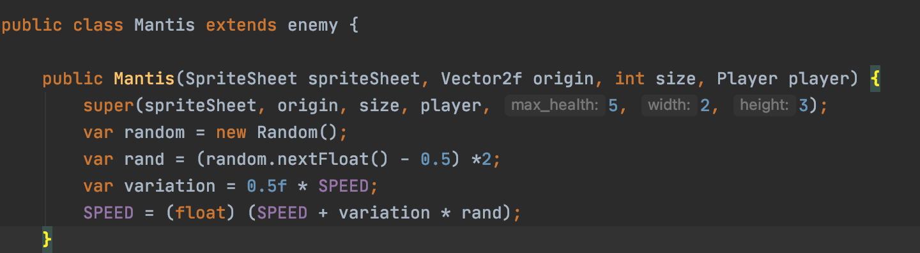

# 4.11 ENEMY MOVEMENT

As Enemy extends entity I proceeded to use the same methods already set out for the enemies such as the die() function, attack and movement directional values as well as onAnimationFinished as the attacks needed a lapse between them running. The update() method however is certainly something to note as it controls when the sprite needs to move towards the player or when it needs to attack the player.

This method essentially uses a combination of if conditions to make its decisions. If is_attacking is set to true then the Vector MoveTowards() function is called causing the enemy to make its way towards the player, the players position and speed of the enemy is passed as a parameter. While the enemy moves towards the player a check is also done within the loop to see if the minimum distance requirement is satisfied so the enemy can attack. If it isn’t the enemy continues to make its way to the player, when it is within the minimum distance to attack the enemy the enemyAttack() is called. This method references the direction the enemy needs to face when attacking and the attacking itself to inflict damage on the player from the Enemy class. Following the loop this a direction variable is implemented so the animation knows which direction it needs to turn in when making its way to the player as the player is usually moving at the same time, this uses a method in the Vector class which will be expanded upon later in the report.

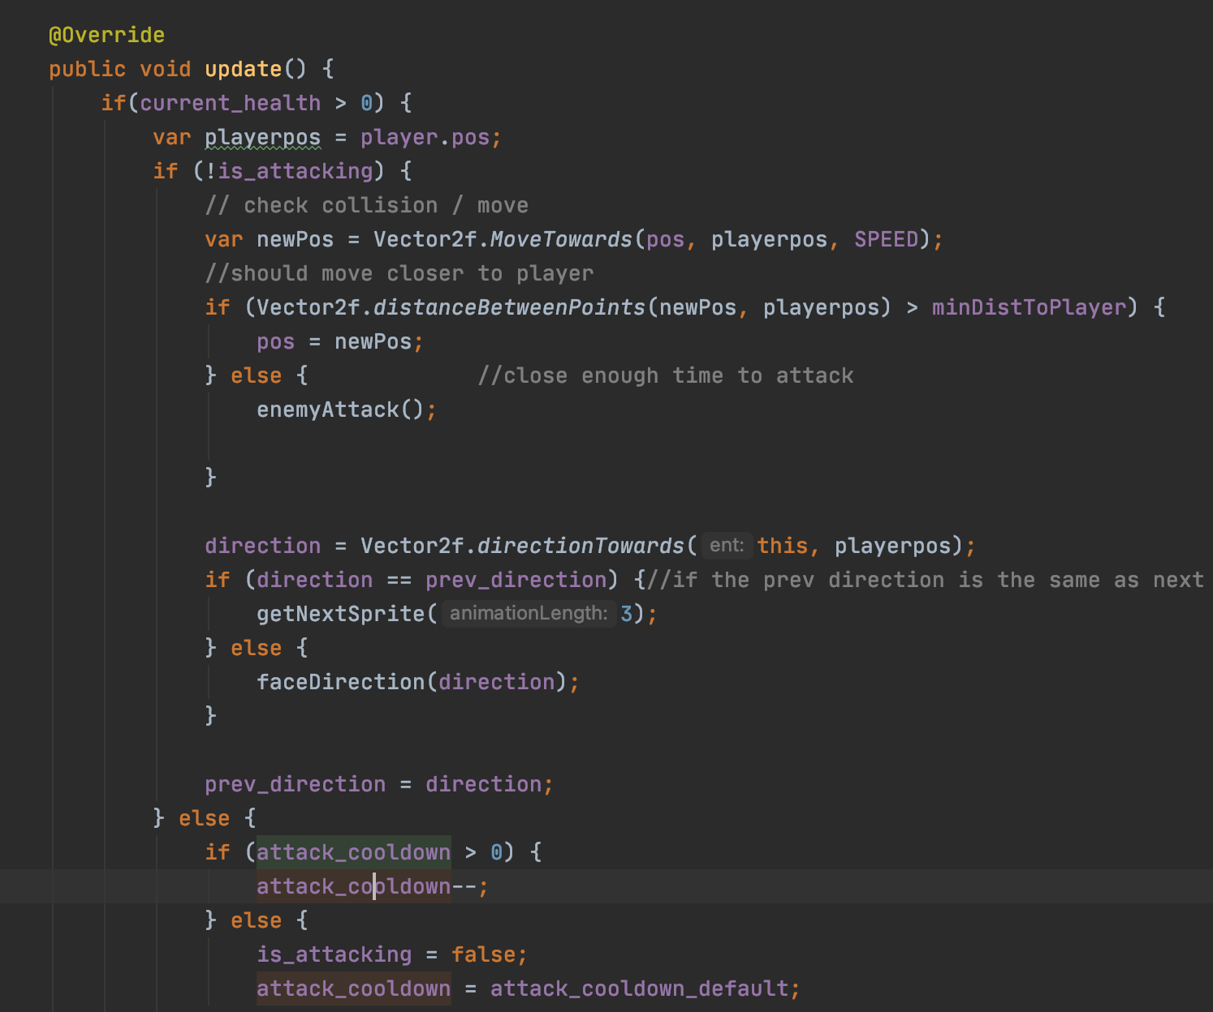

# 4.12 INFLICTING PLAYER DAMAGE

Below details the method that details how the enemy inflicts damage on the player, here we see that if the player is in range of the enemy, the enemy will activate its attack. The will cause the player to take attack damage, decrementing his health by 1 each time. If the player is dealt too much damage, he will die.

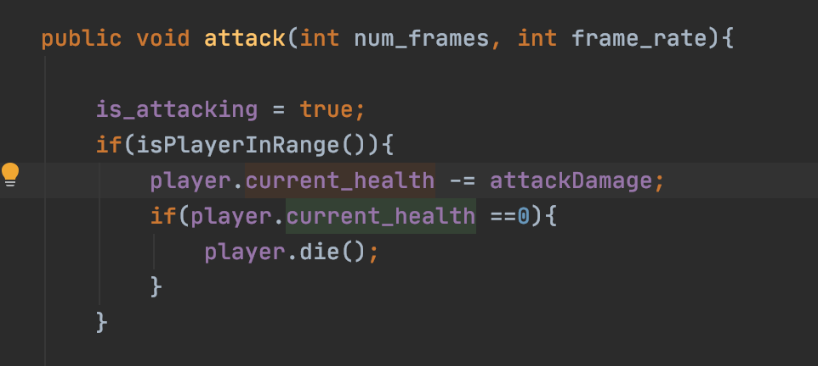

# 4.13 GAME LEVEL SETUP

Progressing on from this step I also decided that it would be a good idea to establish some props that would act as barriers in the game. The reason for this is so that when the player is moving around the map their movement is restricted since the barriers rendered on to the screen use collision detection meaning the player cannot move through them and must go around them. I believe this acts as a positive feature of the game as it encourages the player to move around less and coupled with the enemies’ path finding mentioned earlier, it prompts the player to attack the enemies rather than passively run around.

The way the props are made is shown in the below screenshot. Here we can see that an array list ‘props’ is created that extends the Prop class object which was created in the Entity package. This is where any props that need to be generated and rendered would be added but in this instance I only used one prop to randomly generate.

Then, within the setupLevel function the random function is assigned to variable rand and propcount is set a randomly generated number within 20 and a for loop is made to iterate through the items in propcount. Within this loop I also establish vectors for the player and the positional values ill be using to set up the collision detection which will be implemented in the canMove() function. I use the players bottom right as a starting value and assign those values to an X and Y and include the players current position and size so detection can be used all around the player.

I then create a condition within the for loop so check if any props overlap with each other, I did this by creating variables to hold the position of the objects which is like how I established the detection bounds for the player. I then iterate through the number of props in the list which in this case is 20 in total and get the elements using props.get(k). I then use an OR condition operator to construct a statement using the Overlapping method I created on line 386. This condition takes 4 positional values and checks if there’s an overlap between props or if there’s an overlap between a prop and a player meaning if the props spawn over the sprite, then retry generating the props until there isn’t an overlap.

This helped set the game level out cleanly and fixed the issue of objects looking bugged by overlapping over themselves as they spawn at random locations every time the program is run. Once all these conditions are checked and met the variable ‘rock’ I created which references the prop sprite is then loaded and is added to the array list props and added to the instantiation of class Renderable. [A301423-25](https://cseejira.essex.ac.uk/browse/A301423-25)

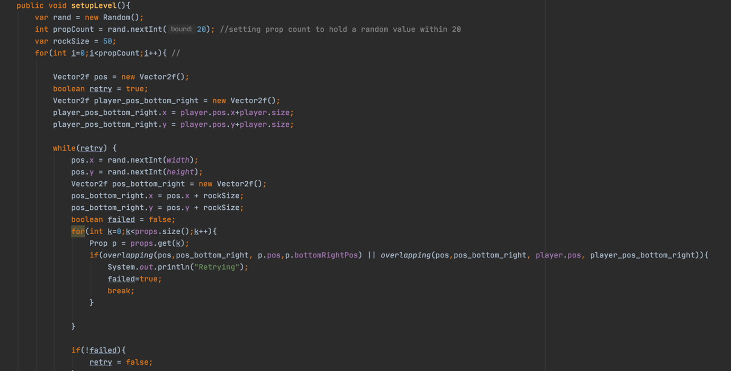

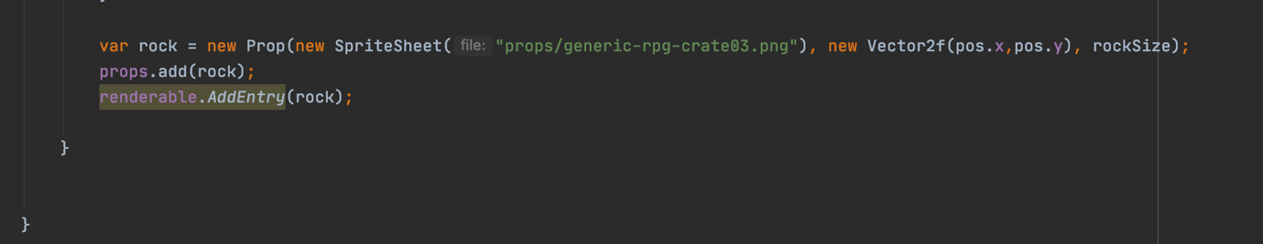

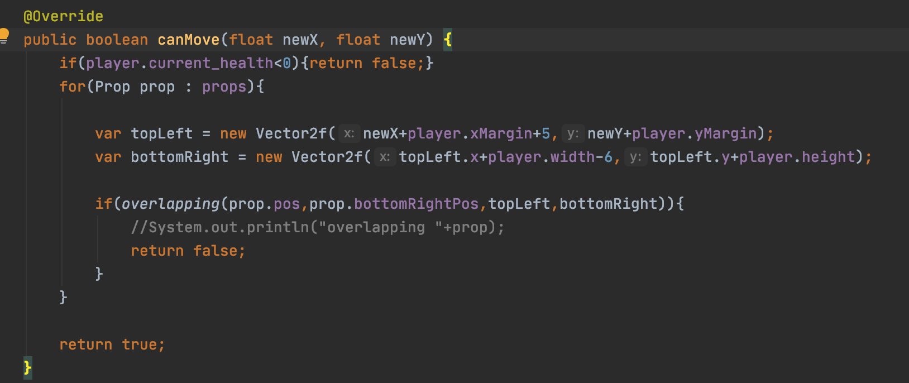

# 4.14 WAVE GENERATION & SCORE TRACKING

Moving forward, the next mechanic to be discussed would be the wave generation and score counter. In terms of creating the wave generation it wasn’t too difficult since all enemies are stored in an array list. The wave creation is handled in the function startWave() within class Game and takes the number of enemies as a parameter. It contains two if conditions and a for loop. The first condition essentially sets out the case in which the health bar regenerates for the player and the condition to satisfy this is when the wave number is divisible by 5, modulo is used to make sure the number is divisible by 5 with no remainder as I used ‘is equal to’ and set it to zero. This means every 5th ,10th or 15th etc round, the regeneration condition is triggered. The second condition within the function dictates the creation of my boss sprite which is the beetle and this is generated every third round. Finally I used a for loop to iterate through ‘numofenemies’ and called the createMantis() function to generate the enemy and passed a negative X coordinate so it spawns just off the left side of the screen and used a randomly generated Y so they don’t always come out of the same spot.

The wave counter was straightforward to implement, it was a matter of setting a variable ‘wavenumber’ at the top of my Game class to zero then incrementing it in run() every time the enemies list was empty, i.e. when they were all killed. Every time a new wave is incremented start wave is called generating a new set of enemies.

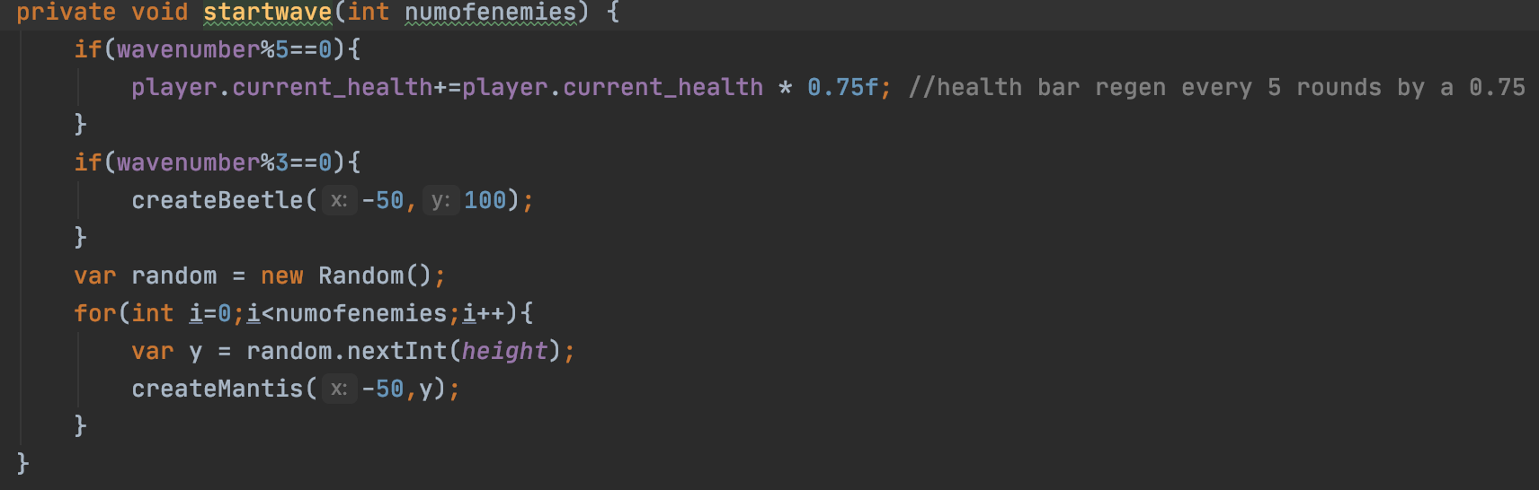

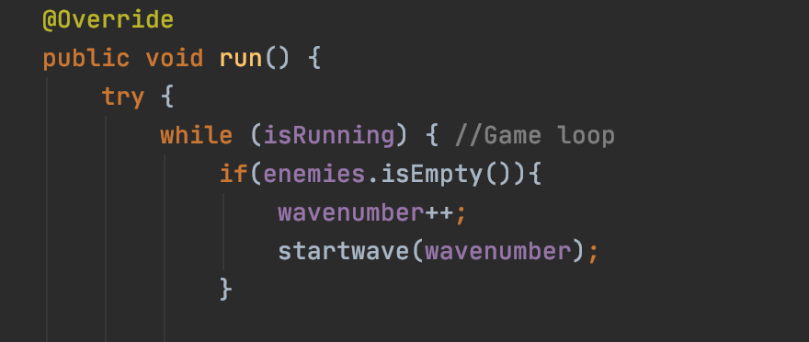

Its also important to note than within the run method the player inflicts damage to the enemy as the decrementing of its health is handled here. [A301423-45](https://cseejira.essex.ac.uk/browse/A301423-45)

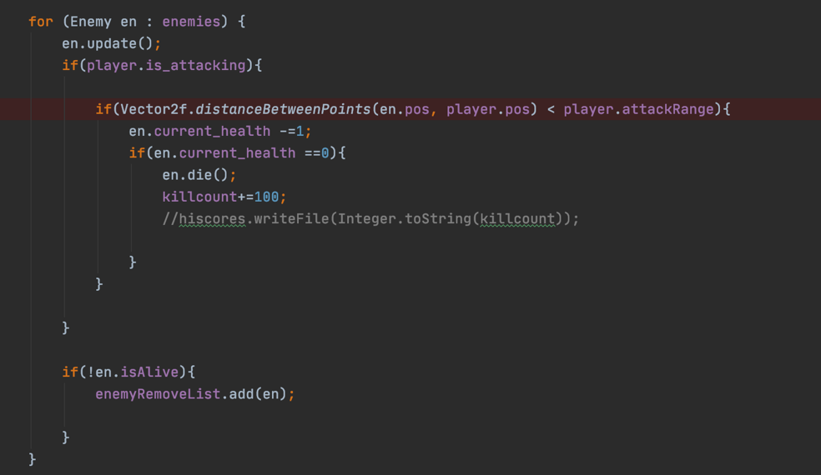

Once the logic was created for the health bar and wave counter, I then had to paint the graphic it on to my game panel. [A301423-40](https://cseejira.essex.ac.uk/browse/A301423-40)

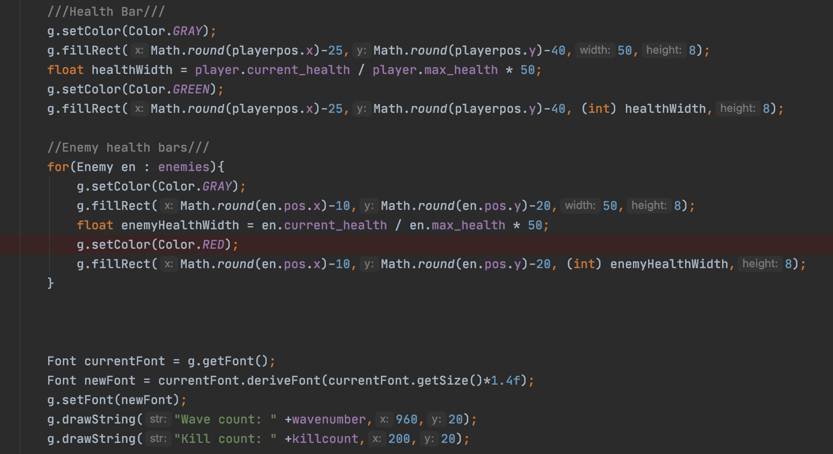

# 4.15 THE VECTOR CLASS

Within the Vector2f class are a number of methods that have been adapted and modified for their own unique functions. Notable functions within this class include the moveTowards() method which is utilised by the Mantis and Beetle class. This method takes the current position of the enemy and the target position of the player and a speed variable to move towards it. Another method within this class is the distanceBetweenPoints() method which takes 2 positional vectors and finds the distance between the enemy and player. I use as pre condition to see if its less than the attack range and if its is then the entity in question will attack, the Boolean is_attacking will register as true and this will cause the enemys health to decrement. This was implemented in the Game, Beetle, Mantis and enemy class as a variety of similar conditionals.

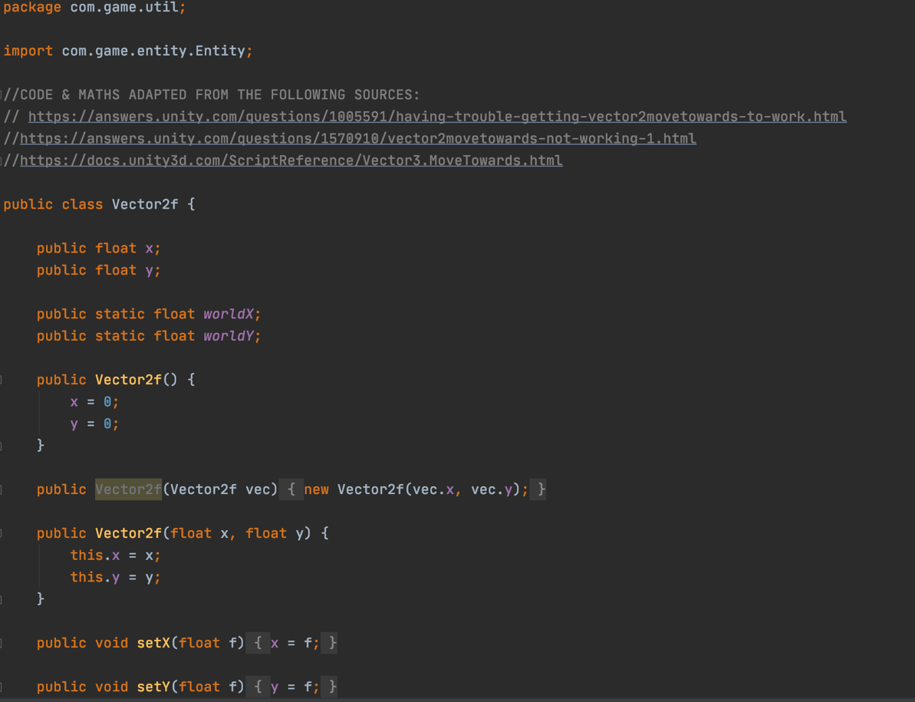

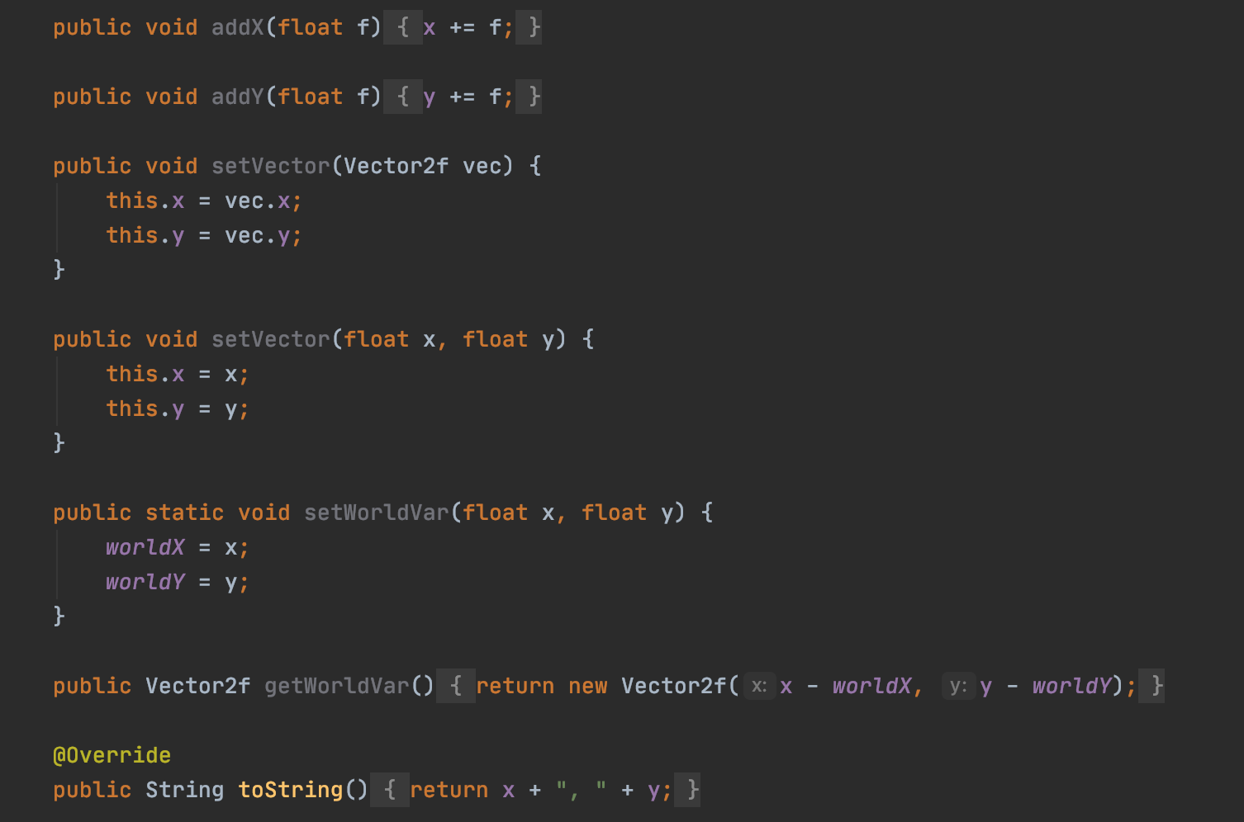

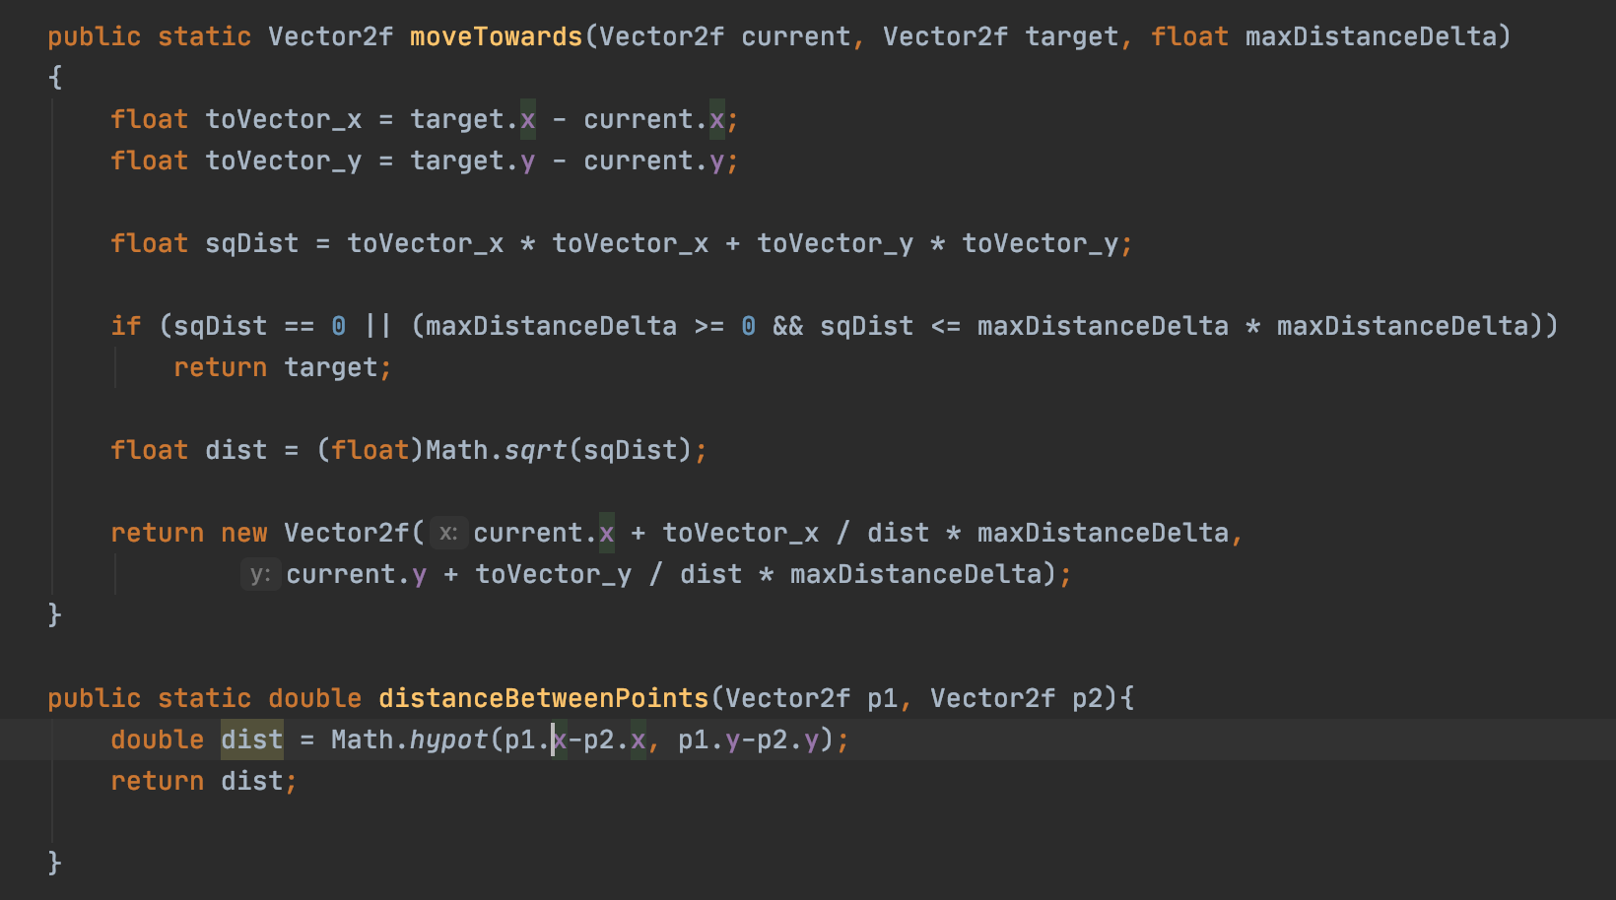

The getAngle() method words in conjunction with the directionTowards() method. It essentially uses 365 degree angle to determine which direction the animation should move in so it is facing the correct way when it needs to turn when path finding towards the player. The maths is fairly straightforward and was developed by myself and uses angles within a 4 set of ranges and for each range it has a directional value which is referenced from the Values class which was discussed in an earlier technical description.

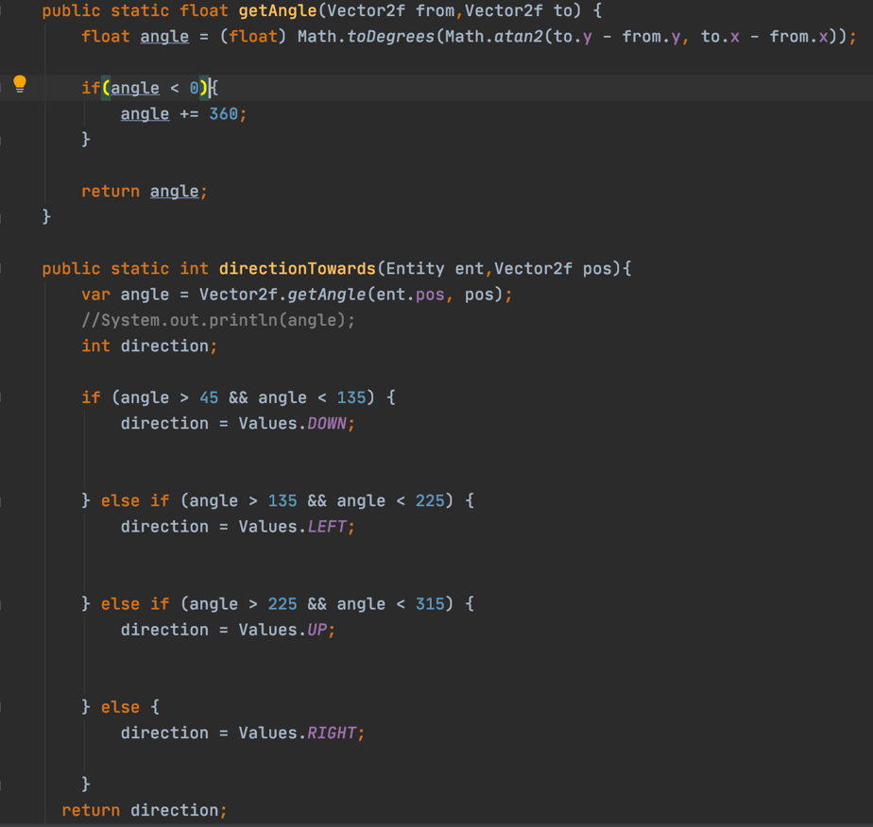

# 4.16 ANIMATION TIMER

Here runnable is implemented for objects that intend to be executed by a thread. The thread itself generally uses an empty run() implementation method but here it’s been implemented so that it can be applied to sprite animations to make the attack animation for entities smoother rather than being slow and incrementing through frames as it would not be good gaming practice to have an attack that appears to lag. Essentially its used when attack animations are being set in the attack methods, a new AnimationTimer is created for each entity attack and it uses the parameters shown in the screenshot below. A pre delay is used in the enemy class so the enemy doesn’t repeatedly attack the player at a fast speed when in range of the player as it would kill the player in a matter of seconds. This is shown in the following screen shots. [A301423-31](https://cseejira.essex.ac.uk/browse/A301423-31)

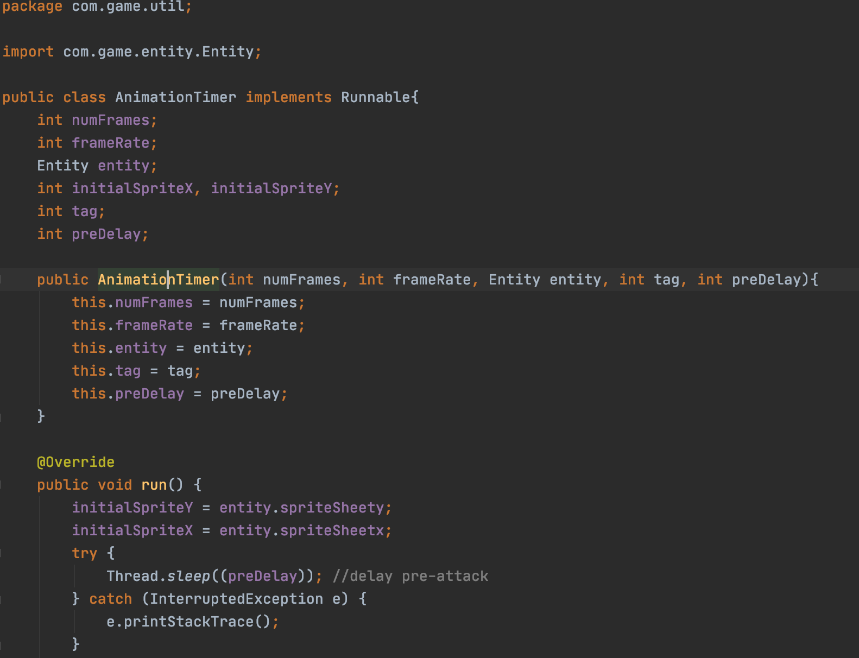

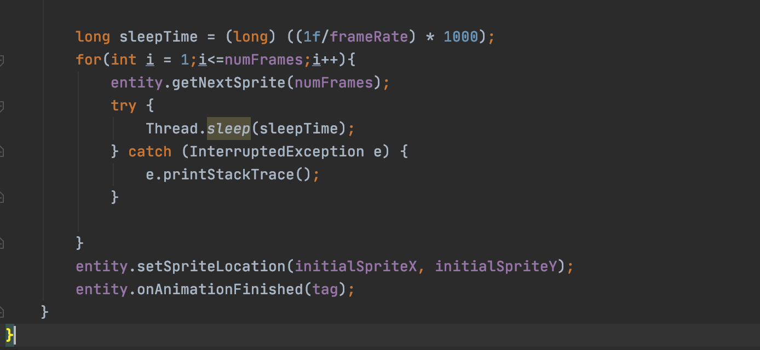

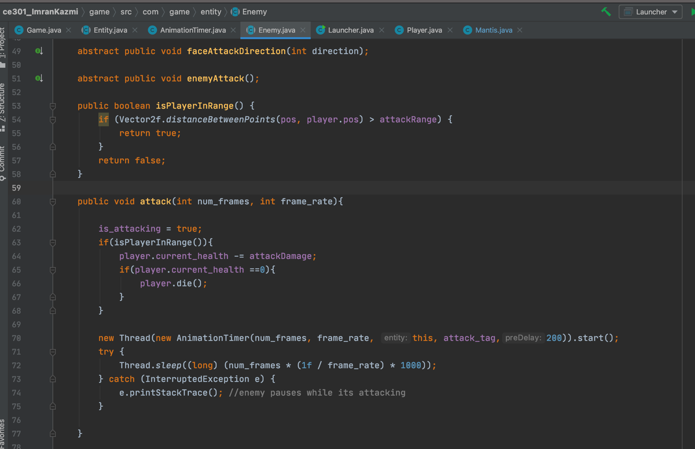

# 5 PROJECT PLANNING

Throughout the project I have worked consistently throughout the year to ensure I have a finished product in terms of playability and cohesiveness within my program. My focus was to produce good quality code that is dynamic and easy to understand.

Throughout each stage of development, from the challenge week to the MVP demonstration in the oral review ([A301423-12](https://cseejira.essex.ac.uk/browse/A301423-12)) I believe I have managed to meet the expectations I had set out for both timeframes to an extent. The reason I say this is because looking at the ticket for the MVP deliverables there were some elements which I didn’t manage to meet in the specified timeframe such as creating a menu system and implementing a health system. The reasons for this were because I had spent a lot of time making sure the code I had created did not contain any bugs as I ran in to issues with making sure the attack animations were smooth and working. Threading was used to process the attacking mechanism and a timer was applied to make it smooth as well as debugging collision detection to make it as accurate as possible. Despite falling short on a few areas for the MVP I had still managed to achieve the majority of points set out as explained in the week 11 presentation and have since met all the requirements I had set out at the present time.

Shown below is a cumulative flow diagram. This demonstrates the status of issues over time from the start of the project to current date. It helps identify if there were any bottlenecks in the workflow. Analysing the graph below its clear to see that in the month of October when the project began there wasn’t many tickets being raised as I had not been keeping up with documenting tickets but shortly after I began to document my progress a lot more and began consistently logging and completing tasks as demonstrated by the rate at which tickets were completed shown in purple. The items in orange toward the current date are feedback set by my supervisor and I decided to leave them in the to do section as they were not tasks set and created by myself so it wouldn’t make sense to complete said tickets. Reasons for latency in the dates of February and March also include academic term dates and the same can be seen mid-December and January where I had taken some personal time for myself.

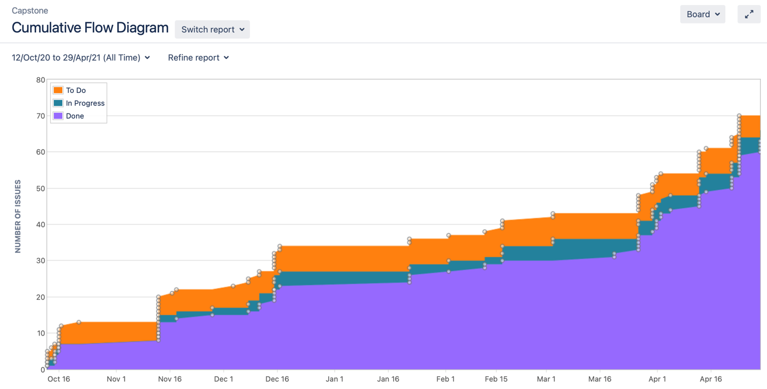

Pictured below is also a screen shot of my Kanban board as of the 29th of April. Here it’s clear to see the to do includes assessor feedback which isn’t relevant to the project’s workload and the total amount of issues completed which is at 64. Some issues were more complex than other and the time frames to complete each ticket all vary but looking at an overview of this I think I did a good job at documenting the implementation and design process for my game.

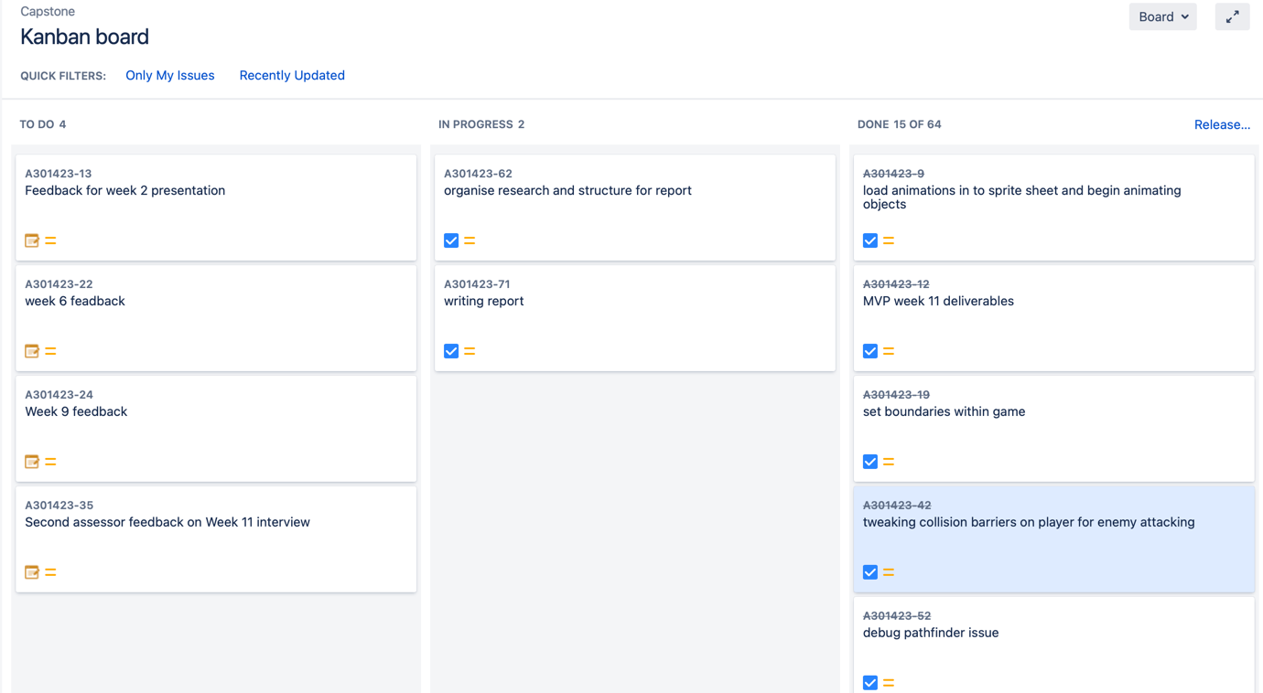

In terms of risk management, it is important to think about what can go wrong so I can be proactive instead of reactive. The result of not using good risk management practices is that the potential risk can become a real issue if not addressed properly. I used risk management in the project where I followed a framework for what I wanted to create first as I knew some issues would take more time to figure out than others. For example, I decided to implement collision detection on my project at a fairly early stage as I knew that this would be something that would take time ([A301423-25](https://cseejira.essex.ac.uk/browse/A301423-25)) in terms of registering collision/overlaps and trimming the players detection to make sure its as accurate as possible. Some could say it would’ve made sense to maybe start with the menu system or the UI as that’s what the user will interact with upon first launching the game but i suspected that the UI although important should assume a lower priority over other technical aspects which is why I implemented this towards the end of my project([A301423-68](https://cseejira.essex.ac.uk/browse/A301423-68))as it had a low risk of presenting issues. This meant that if I had issues implementing the menu system it wouldn’t impact the project as much as having issues with detecting collision between the player and enemies as that is an underlying function of the game, this would mean the whole game launch timeframe would have had to be pushed back if it needed debugging.

# 6 GAME TEST RESULTS

The results from the below diagram are from 2 sets of differing age groups, one set is from a male and female aged 13 and the second set are from two males aged between 21 – 22 (2 family and 2 friends). The following results are interesting to look at as its very difficult to assume there is no bias with their opinions however, I believe the results demonstrate a balanced viewpoint between two different groups and provides a good insight in to the satisfying the needs of both audiences in question.

|  |  |  |  |  |  |
| --- | --- | --- | --- | --- | --- |
|  | On a scale of 1 - 5, how do you feel about the design theme of the game? 1 being very bad and 5 being very good | On a scale of 1 -5, how easy was it to use the controls? 1 being very bad and 5 being very easy | On a scale of 1 - 5, how difficult did you find the gameplay? 1 being very hard and 5 being very easy | On a scale of 1 - 5, how likely would you be to play this game again? 1 being very unlikely and 5 being very likely | Additional comments |
| Female child | 3 | 5 | 2 | 2 | “I found it hard to play the game since I don’t like playing them a lot” |
| Male child | 4 | 5 | 3 | 4 | “I like how it’s easy to see how to use the controls” |
| Male adult | 4 | 5 | 4 | 3 | “I liked how the main player looks, it reminded of Zelda” |
| Male adult | 4 | 5 | 3 | 4 | “it took me a few tries to get used to playing the game, but It wasn’t too difficult” |

# 7 ETHICAL & MORAL CONSIDERATIONS

When creating a product for consumer production its especially important to consider the ethical and moral implications of releasing said product into the public. As seen above in appendix 1 we were able to see the effect of covid –19 in relation to the amount of time the average country spends playing games and we saw a global increase across all countries with some even increasing by 45%. The effect of this is that people were spending a lot more time inside the house playing games, it is unknown whether the games played are multiplayer, where they would be interacting with other people or not as that is data that is not available at this point in time.

This was understandable seeing as many countries in the world had national lockdowns meaning people couldn’t leave their house as often as they would. However, within the Western world and particularly the UK as more vaccines are rolled out, the nation is coming out of lockdown.

This means the government are now trying to encourage more people to integrate back into the outside world and work/social life in order to stimulate the economy and resume normality. This is important to note as due to the average gaming time for a person who plays video games has increased it can be assumed that people have become accustomed to the habit of playing games for a long period of time, this is known as a gaming addiction. This is relevant to my project as I have created a game for people to play however would this only contribute to more people spending time inside playing games and worsening their addiction and therefore impact their social skills and life?

Another viewpoint to consider is a licensing issue with regards to the game. This could be an issue as the main players character is taken from the Super Nintendo series The Legend of Zelda meaning using the character in my game is a violation of copyright law and therefore it would be the businesses prerogative to remove the players likeness from my game.

# 8 CONCLUSION

In this report I explained the design and development process I went through in order to create my game with java programming. I have discussed the background research that went in to developing the themes of my game as well as the sources I used to influence the implementation of the game. Throughout the process I have found that developing a complete game is a long process that involves multiple iterations of creation in order to create a game that engages the user and that without a good sense of risk management and planning it would have been extremely difficult to develop a game on this scale, especially with the number of classes that I created and implemented.

I learnt a lot through creating this game including how use graphic design software such as Photoshop to create and animate sprites and UI graphics. I also learned about more about the benefits of extending classes, the use of subclasses and the role the parent class plays in making re-usable and dynamic code, this can even be seen in my discussion of the Entity class and how the Player and Enemy classes access and use the attributes defined in Entity. I also learned about a lot of issues that I didn’t realise would be an obstacle in developing my game such as memory leak errors after I tried to render myenemies as I wanted to leave their bodies on the panel after they died for graphic effect. This wasn’t feasible as all the sprites were being rendered and animated and there simply wasn’t enough memory to leave the dead enemies on screen.

I was also able to explore the benefits of using threads in my program where I was able to use threads on my attack mechanism for speedier processing and even using techniques like applying timers to my animations for enhanced playability. Not only was I able to increase my knowledge of programming in java but I was also able to improve my coding practices and had the creative freedom to take this project where I wanted to go which was especially important to me as a programmer.

I also realised the quality of game comes to individual creative choices where the game is only as good as you make it. I wanted to push myself and explore a new area of programming as I’ve never developed a game before, I could have probably stuck with a simpler game of checkers or brick breaker which would have satisfied the classic arcade game need, but I wanted to show off my creative thoughts and decided to pursue something more interesting and interactive like animating 2D objects.

If I could start the project again, I would have made a few tweaks to the mechanics of the game as I’m very happy with how the overall game came out and even find myself playing it for fun at times. These changes would have included areas such as implementing a more complicated pathfinder algorithm such as Dijkstra’s algorithm which finds the shortest path between two given nodes. I decided not to initially pursue this as my AI knowledge is very limited and using risk management, spending time trying to implement this would’ve thrown my launch time frame off. However, I do believe I compensated on this issue by adding speed variation amongst my enemies. Other areas also include small changes such as adding in power ups for the player, but I think I compensated for this well by adding in health regeneration as a bonus. I also would have liked to add in a separate score tracking system that can be accessed from the menu, where it reads and writes from a file storing scores and outputs it on to a score screen with the players name as a scanner input and the score they achieved in the games they’ve played.

To conclude I believe I have produced my own modern-day adaptation on a 2D classic arcade game by taking elements from old and new times, paying homage to nostalgic gaming using the Super Nintendo Link character and adapting the gameplay from my own experience. The game that has been presented is a creative yet simplistic way that implements well thought out and logical code.

# 9 REFERENCES

[1] Codegym. (16 Oct. 2019). Java Game Programming For Beginners: Where to Start[Online]. Available: <https://codegym.cc/groups/posts/182-java-game-programming-for-beginners-where-to-start>

[2] Nadia Stefyn. (23 Oct. 2019). How Video Games Are Made: The Game Development Process [Online]. Available: <https://www.cgspectrum.com/blog/game-development-process>

[3] Richard G Baldwin. (27 Sept. 2001). Java Game Programming For Beginners: Where to Start[Online]. Available: <https://www.developer.com/java/other/article.php/893471/Fun-with-Java-Sprite-Animation-Part-1.htm>

## [4] Gamefaqs (Date unknown) The Legend of Zelda: A Link to the Past [Online] Available:

<https://gamefaqs.gamespot.com/boards/588436-the-legend-of-zelda-a-link-to-the-past/44743193>

[5] Insect enemy assets (Date Uknown) Downloadable asset packs [online] Available: <https://jeevo.itch.io/insect-enemies?download>

# 10 ADDITIONAL NOTES

**Please note:** As discussed and agreed with by my supervisor, the screenshots included in the report are from the program before it was commented, upon demonstration of the code it will be visible to see the program complete with all classes commented.

# 10.1 APPENDICES

**Appendix A:**

